UCF PEGASUS PLAN - 2nd Grade - Supply & Demand
Renata Veronica Nunez Saenz, Valeria Bonilla, Julia Buquicchio, Leah Silverman, and
Mya McCormick

National Council for SS Themes:
People, Places, and Environment
Production, Distribution, and Consumption
Individuals, Groups, and Institutions

Social Studies Standards:
SS.2.E.1.1 Recognize that people make choices because of limited resources.
SS.2.E.1.2 Recognize that people supply goods and services based on consumer demands.
SS.2.E.1.4 Explain the personal benefits and costs involved in saving and spending.

B.E.S.T. Standards:
ELA.2.C.2.1 Present information orally using complete sentences, appropriate volume, and clear pronunciation
ELA.2.R.2.2 Identify the central idea and relevant details in a text.

Unit Goal:
The student will | understand supply and demand, consumers and goods, and recognize the benefits of saving and spending.

Unit Scale:
4 …and can teach it. | Understand that a community needs goods and we use the money to consume those goods, and can teach these concepts
*3 (Mastery) I can | Understand supply and demand, consumers and goods, and recognize the benefits of saving and spending
2 With support, | Identify what a community needs vs wants and how we use supply and demand to accommodate those wants and needs
1 …yet. | Describe how supply and demand relate to saving and spending

UDL Principles: UDL Website
UDL 1.1 Representation - Perception: Offer ways of customizing the display of information.
UDL 2.1 Representation - Language and Symbols: Clarify vocabulary and symbols.
UDL 5.2 Action & Expression - Expression and Communication: Use multiple tools for construction and composition.
UDL 7.1 Engagement - Recruiting interest: Giving students choice and autonomy to increase engagement with the material that is taught.
UDL 9.1 Engagement - Self Regulation: Promote expectations and beliefs that optimize motivation.

ESOL Strategies: ESOL Resources
ESOL 4: Link lesson topic to students’ prior knowledge
ESOL 10: Promote cooperation (small groups)
ESOL 17: Use realia and pictures whenever possible.

Technology: ISTE Standards for Teachers

1.3.b Evaluate Information: Students evaluate the accuracy, perspective, credibility, and relevance of information, media, data, or other resources.

1.6.c Models and Visualizations: Students communicate complex ideas clearly and effectively by creating or using a variety of digital objects such as visualizations, models, or simulations.

1.6.d Customize the Message: Students publish or present content that customizes the message and medium for their intended audiences.

Unit Outline
Day 1: | Shops, Shops, Shops! Goods and services that are here for me
Day 2: | The Great Supply and Demand Adventure: Unraveling the Mysteries of Buying and Selling!
Day 3: | Prices, Prices, Prices: Why do they go up and down
Day 4: | Supply and Demand: We love Candy!
Day 5: | Supply and Demand: How are Goods Made
Day 6: | Review: Supply and Demand: We want more Candy!
Day 7: | What does it mean to spend and save money
Day 8: | How do we spend and save money
Day 9: | Needs, Wants, Spending, and Saving
Day 10: | Understanding Needs vs. Wants
Day 11: | Making Smart Spending Choices and Introduction to Classroom Store
Day 12: | Creating Your Own Business: Using Supply & Demand
Day 13: | Production of Goods
Day 14: | Classroom Store Day 1
Day 15: | Classroom Store Day 2 and Post Assessment (Kahoot)

Unit Plan: Grade 2- Supply & Demand - Economics

Days 1-3: Supply & Demand by Miss Veronica Nunez Saenz
UNIT Learning Goals A learning goal describes what students should be able to DO by the end of the unit.
- Students will be able to explain supply and demand.
- Students will be able to explain how the price of a product is affected by demand.
Essential Question(s) Students should be able to answer these questions by the end of the lesson to demonstrate their conceptual understanding of new concepts.
- What can happen to the price of a product if many people want it and there isn't enough available?
- Why did the business choose to produce more of a popular item during a certain season?
- How was the supply of a product affected when more people started buying it?

FL State Academic Standards
SS. Benchmarks
SS.2.E.2.1 | Recognize that people supply goods and services based on consumer demands.

B.E.S.T. ELA Connections
ELA.2.RL.2.2 | Identify the central idea and relevant details in a text.
ELA.2.C.2.1 | Present information orally using complete sentences, appropriate volume, and clear pronunciation.
ELA.2.V.1.3 | Identify and use context clues, word relationships, reference materials, and/or background knowledge to determine the meaning of unknown words.

Options for Assessment
Assessment(s)
- Teacher Observation - Anecdotal notes template PDF
  - 
- Teacher Questioning -
  - What is the difference between supply and demand, and how do they work together in the buying and selling process?
  - If the demand for a popular toy suddenly decreases, how might that impact its price?
  - Can you provide examples from your own experiences that illustrate what a supply is and what a demand is?
- Alternative Assessment - Informally assess students' understanding throughout the lessons by observing their participation and engagement in activities. Review the completed worksheets to gauge comprehension.
Vocabulary
- Price: The amount of money you must pay to buy a product or service.
- Market: A place or a system where buyers and sellers come together to exchange goods and services.
- Goods: Physical things that people make or grow, and that can be bought or sold.
- Services: Actions that people do for others, usually for payment.
- Buyer: Someone who pays money to get a product or service.
- Seller: Someone who provides a product or service to others in exchange for money.
- Supply: The amount of a product or service available for people to buy or use.
- Demand: How much people want a particular product or service.
- Buyer: Someone who pays money to get a product or service.
- Seller: Someone who provides a product or service to others in exchange for money.

Instructional Guide
Focus | Pacing* | Instructional Sequence
Preview/Motivate  Slide Deck  Classroom Activity  Role-Play | 15 minutes  (5 minutes each day) | - Setup: Arrange the classroom to resemble a marketplace with different stations representing various goods and services. Use tables or desks to display items such as toys, books, snacks, and art supplies. Designate areas for services like haircuts, face painting, or storytelling.  - Assign Roles: Assign each student a role as either a buyer or a seller. Encourage creativity by letting them choose or invent their own characters, such as a toy shop owner, a baker, or a customer looking for a special gift.  - Introduction: Start by explaining the concept of supply and demand in simple terms. Emphasize that buyers want to buy goods and services, while sellers provide those goods and services in exchange for money.  - Role-Play: Let the role-play begin! Allow students to explore the marketplace, buying and selling items or services. Encourage them to negotiate prices, consider supply and demand, and make decisions about what to buy or sell.  - Reflection: After the role-play session, gather the students to reflect on their experiences. Discuss what they learned about supply and demand, how prices were determined, and any challenges they encountered during the activity.
Vocabulary  Classroom Activity Slideshow - Vocab slides | 15 minutes  (5 minutes each day) | Develop key vocabulary. Introduce key terms: supply, demand, cost, production cost, producer, consumer.  - Introduce the vocabulary words in the lesson.  - Refer to the worksheet that is glued on students’ journal.  - The vocabulary is listed on each day.  - Price: The amount of money you must pay to buy a product or service.  - Market: A place or a system where buyers and sellers come together to exchange goods and services.  - Goods: Physical things that people make or grow, and that can be bought or sold.  - Services: Actions that people do for others, usually for payment.  - Buyer: Someone who pays money to get a product or service.  - Seller: Someone who provides a product or service to others in exchange for money.  - Supply: The amount of a product or service available for people to buy or use.  - Demand: How much people want a particular product or service.  - Buyer: Someone who pays money to get a product or service.  - Seller: Someone who provides a product or service to others in exchange for money.
Procedures  Day One Lesson Plan  (see detailed lesson plan above for day one only)  Classroom Activity Slideshow slides 7-15 Hands-On Activity slides | 45 Minutes  (15 minutes each day) | Note: Throughout this unit, students will be given handouts etc. that should be glued into a social studies journal.  Day 1: Students will describe and identify the differences between goods (use realia such as food, shoes, cars, and houses) and services (physically intangible things such as medical care, and education). (Slides 7-9)  - Start introducing the vocabulary and play the video  - Have students sing the song multiple times and then gauge their vocabulary comprehension.  - Lastly, choose one of the two activities:  - Option A: White Board Showdown UDL 4.1  - Using the “Goods and Services in the Community PDF” worksheet, pick five goods and five services and choose a picture to represent each one.  - Show students the pictures -UDL 5.1 and have them right down the answers on their whiteboards. Make sure to use simple terms and to keep instructions short and simple -EL 14. Annotate the names of students who get an answer wrong -EL 6. Students should correctly answer 3/5 of the pictures of goods and services.  - The short prompt using pictures (visual cues) will help support students with academic support needs rather than just having the word up on the board.  - Option B: Activity sheet - Make sure that it is glued on their journals.  - Distribute the Activity worksheet titled “Goods and Services in the Community PDF”  - Either read each prompt to the students and give them time to circle the correct answer before moving on to the text to guide them -EL 22, or et them read it on their own and walk around the classroom monitoring their work -UDL 7.1.  - Students should answer at least 7/10 questions correctly.  - Keep and use their worksheets to identify how much the students understand the new concepts -EL 6.  Day 2 - Students can understand and explain in their own words the differences between supply (the amount there is of something) and demand (how much people want it). (Slides 11-12)  - Start the lesson by making a quick review of the terms we learned on Day 1.  - Re-play the goods and services song, or ask students “What is the difference between a good and a service?”  - Bringing all the kids to a reading area and read “What is Supply and Demand?” by Kelly Lee to them. If need be, use this link for a Read-Aloud:  - Before: Ask students what they see on the cover and what they think will happen in the story. Tell them to keep an eye out for words that are unfamiliar to them.  - During: Stop reading at keywords, such as supply, demand, cost, price, lower, and increase. Write the keywords on the whiteboard. Also ask students what they think will happen when the price lowers.  - After: Tell students what the words supply and demand mean. Ask them how knowing the meaning of this word has affected their view of the story. Why did the main character feel the need to create a marshmallow cookie sandwich? Make sure students make the connection that since the weather was cold, there was a low demand for ice cream sandwiches.  - Review the words that students mention and write down the definitions for each one on the board for students to refer to throughout the unit. If they did not mention a key vocabulary word, make sure to include it.  - Supply: The amount of a product or service available for people to buy or use.  - Demand: How much people want a particular product or service.  - Buyer: Someone who pays money to get a product or service.  - Seller: Someone who provides a product or service to others in exchange for money.  - Price: The amount of money you must pay to buy a product or service.  - Market: A place or a system where buyers and sellers come together to exchange goods and services.  - Exit slip, have students answer the following questions:  - What is the difference between supply and demand?  - What is the difference between buyer and consumer?  - List 1 example of supply and 1 example of a demand.  Day 3: Students begin to think about and understand why prices increase and decrease, and the effect this has on consumers. (Slide 13-15)  - First ask students what they remember about the book “What is Supply and Demand?” by Kelly Lee. If they don’t remember much, give a quick summary.  - Guiding questions: What happened when the bunny reduced the prices of his ice cream sandwiches? How did this affect the demand?  - For the next activity set up two baskets with the same product (i.e.: cookies). In front of one basket set the cookie price for $2 and the other one for $4 and ask students which one they would prefer to buy.  - When students raise their hands and choose the cheaper option, lower the price of the second basket from $4 to $1. Ask students again which cookie they would prefer to buy.  - Have students turn and talk about what just happened. How did the demand for an object affect its price?  - Lastly, set a purpose for viewing the following video. Class, watch the video and listen for vocabulary words and supply and demand concepts we have been learning about over the last three days.  - Watch the following video  - Small group: Students should discuss any additional questions they have and write them down on a post-it so the class can discuss them.
Wrap-Up  Supply and Demand | 15 minutes | When looking at the picture of a busy city street filled with shops, students identify what goods and services are available to them. They demonstrate a deep understanding of supply and demand and the correlation it has with pricing.  - Review the concepts learned over the last three days. Ask students to share aloud. (supply, demand, consumers, producers, etc.)  - Show students a picture of a busy city street filled with shops (slide 15). Next, have students make a list of potential goods and services that would be offered.  - Given the example of an ice cream shop,  - Have students draw an arrow going up or down (to indicate the price increasing and decreasing) on their whiteboard when…  - Demand is high and low.  - Supply is high and low.
Remediation  *This would happen during small group instruction at some other time during ytheday, possibly during ELA. | 20 minutes  (Daily - based on need TBD) | Review the key vocabulary words discussed throughout the lesson and hand out the worksheet “How do supply and demand affect prices”. Students will glue the worksheet in their social studies journal.

Closure
Students start thinking of a good they could offer their classmates. They should explain why they feel their supply will be in demand and who the buyer/consumer will be.

Materials
- 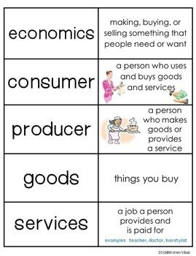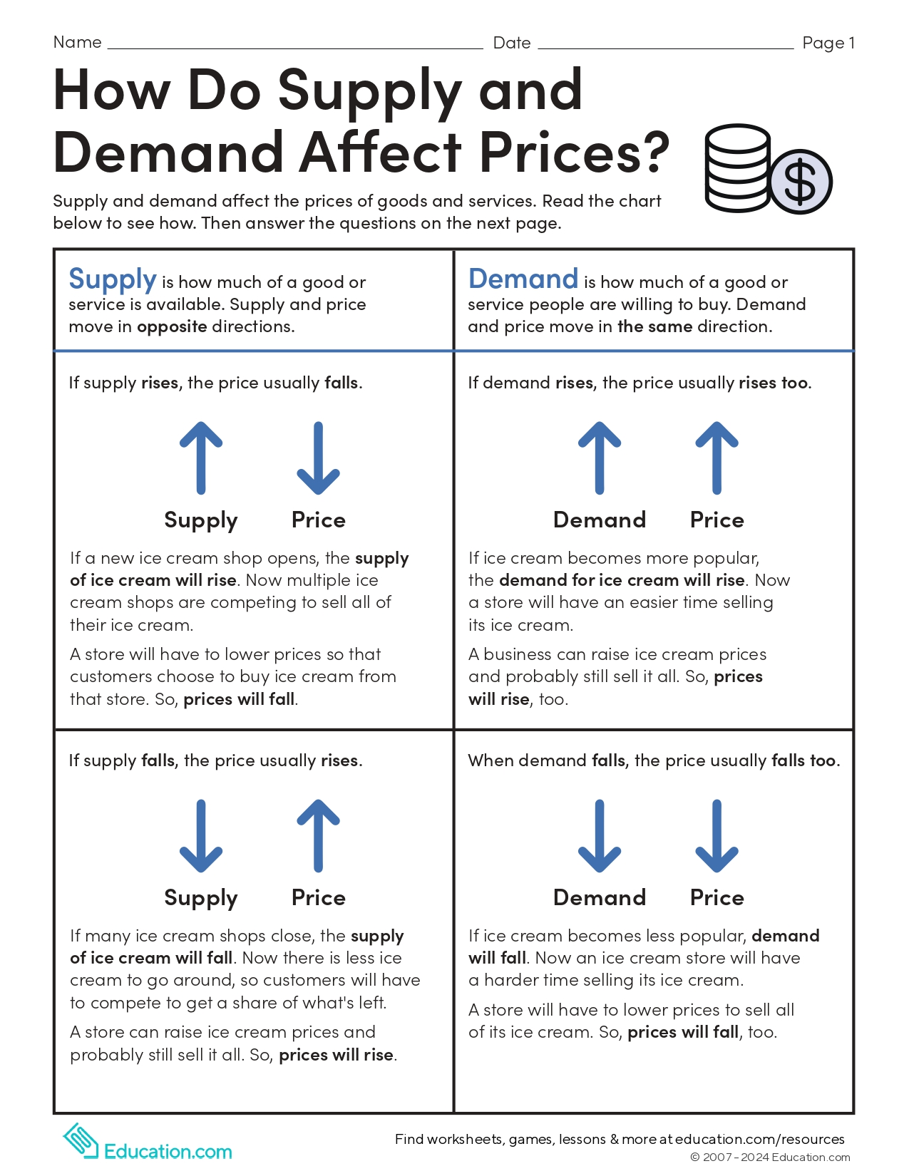
- Vocabulary list
- How do Supply and Demand Affect Prices? PDF
- Read-Aloud: What is Supply and Demand? Read Aloud by Reading Pioneers Academy
- Video Day 3
- Pictures:
  - 
- Materials for Motivation Activity:
  - Cookies or any other tangible object.
- Mentor Text: “What is Supply and Demand?” by Kelly Lee
  - Lee, K. (2022). What is supply and demand?: Fundamental Elements of Most Economics Principles. Econ For Kids.

*Suggested pacing is provided for each part - individual student/classroom needs may differ*

Days 4-6: Lesson(s) Title by Miss Valeria Bonilla
UNIT Learning Goals A learning goal describes what students should be able to DO by the end of the unit.
- Students will be able to recognize that goods and services are based on consumer demands.
Essential Question(s) Students should be able to answer these questions by the end of the lesson to demonstrate their conceptual understanding of new concepts.
- What can happen if not enough goods are produced to meet the demand?
- Why is it important for producers to know the demand of their goods?
- How does the demand for a good affect its supply?

FL State Academic Standards
SS. Benchmarks
SS.2.E.1.2 | Recognize that people supply goods and services based on consumer demands

B.E.S.T. ELA Connections
ELA.2.V.1.1 | Use grade level academic vocabulary appropriate in speaking and writing.
ELA.2.C.1.1 | Demonstrate legible printing skills.

Options for Assessment
Assessment(s)
- Teacher Observation - Anecdotal notes
- Teacher Questioning -
  - “Is ___ a consumer or producer?”
  - “Is ___ a good or service?”
  - “What happens if there aren’t enough goods to supply a demand?”
- Alternative Assessment
  - Graphic organizer
  - Plickers
Vocabulary
- Goods
- Ingredients
- demand
- Supply
- Production
- Producer
- consumer

Instructional Guide
Focus | Pacing* | Instructional Sequence
Preview/Motivate | 15 minutes  (5 minutes each day) | (Make sure no one in the classroom has any food allergies before this activity. The good can be changed if any student has a food allergy.)  Day 4 Slides 16-23- Tell the students you really wanted candy and went to the store to buy a Snickers bar. Show students the Snicker bar. Ask, “Did the store meet my demand?”. Tell the students that before the candy bar made it to the store it had to be made at a factory. Tell the students that if the Snickers bar factory wants to sell their candy, they will need ingredients to make them.  Day 5 Slides 24-29- Show students the containers with the ingredients discussed the prior day (chocolate, peanuts, sugar, egg whites). Ask, “What is this ingredient?”. Refer to the chart. Remind the students that the producer needs these ingredients to make a good. Access prior knowledge and ask, “The people that make the snicker bar, are they the consumer or producer?”, “how do they make the candy?”, “How are they sent to the stores?”. Write their predictions on the whiteboard.  Day 6 - Slides 30-34: Bring a bag of mini-Snickers bars and tell the students you bought candy from the store and will give everyone candy today. After the students are excited, start passing out the candy. Before you finish, tell the students that you ran out of candy. Tell them the store did not have enough candy for the whole class. Ask, “Did the store I went to meet the demand of the consumer for snicker bars? Why?”, “What should the store do to meet the demand of the consumer?”. (Tell the students that there is a high demand but a short supply. Tell the students you went to another store and bought more Snickers bars so everyone will get candy at the end of the lesson).
Vocabulary | 15 minutes  (5 minutes each day) | Day 4 - Review the vocabulary chart. Ask “Is the candy a good or service? Why?”, “if you buy the candy, are you the producer or consumer? Why?", and “Is the factory/store that makes the candy, the producer or consumer? Why?”. On another chart paper write the word “ingredients”. Define the word and ask, “What do you think are the ingredients of Snicker bars?”. Tell the students they will work in groups to find the ingredients of the Snicker bars.  Day 5 - Review the vocabulary chart. Add the word “production”. Tell the students that after the producer has gathered the ingredients, the good must be produced or made. Ask, “How do you think the snicker bar is produced?”.  Day 6 - Review vocabulary chart. Ask the students to share what they know about each vocabulary word from the chart.
Procedures  Slide Deck | 45 Minutes  (15 minutes each day) | Day 4-  Review from day 1-3. Ask, “What is the difference between supply and demand?”, “If the demand for a popular toy suddenly decreases, how might that impact its price?”. Students will go into groups. Each group will have a slip with ingredients that the teacher previously printed out. Tell the students to talk with each other about the ingredients they recognize. The teacher will give each student a graphic organizer and tell the students they will work on the first box. Students will glue the worksheet in their social studies journal  Day 5- Show the video “How Snickers Chocolate Bars are Made”. After watching the video, remind the students that the video said that millions of people around the world eat Snickers. Ask, “Do you think the Snicker bar has a high demand?”, “What does the producer do to produce enough goods, or snicker bars, for people around the world?”. Students will go back to their groups and work on the second box of their graphic organizer. Students will glue the worksheet in their social studies journal.  Day 6- Tell the students they will work with their group. Give each group a bag or container with a good. The students will read the card along with the goods. The students will discuss if the good has a high or low demand and a high or low supply. When they are done, tell the students they will complete their graphic organizer. Students will glue the worksheet in their social studies journal.
Wrap-Up | 15 minutes  (5 minutes each day) | Day 4- Students will come back together on the carpet. Ask students what ingredients are in the Snicker bar. Write each ingredient in the same chart. Remind them that the goods we buy at the store must be made (produced) by a producer (the producer uses these ingredients to make the goods).  Day 5- The teacher will ask students, “How is the snicker bar, a good, produced?”, “Why are millions of Snickers bars produced?”, “Who is the consumer?” “Does the Snicker bar have a high or low demand?”.  Day 6- Complete a formative assessment using Plickers.
Remediation | 20 minutes  (Daily - based on need TBD) | Students can add the location of their ingredients to a map. They can compare their locations with other groups.  The teacher can show students how another good is made and discuss the process.  The teacher can read aloud “Supply and Demand” by Linda Crotta Brennan.

Closure
-Plickers Assessment

Materials
- Candy bar (Snicker bar) for day 3 and mini candy bars for day 7.
- One ingredient slip for each student for days 4-6.
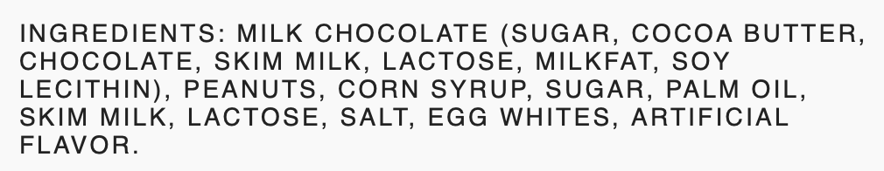
  - Example of an ingredient card
- Example of completed anchor chart paper used on days 4-6 (the teacher will create this with the students).
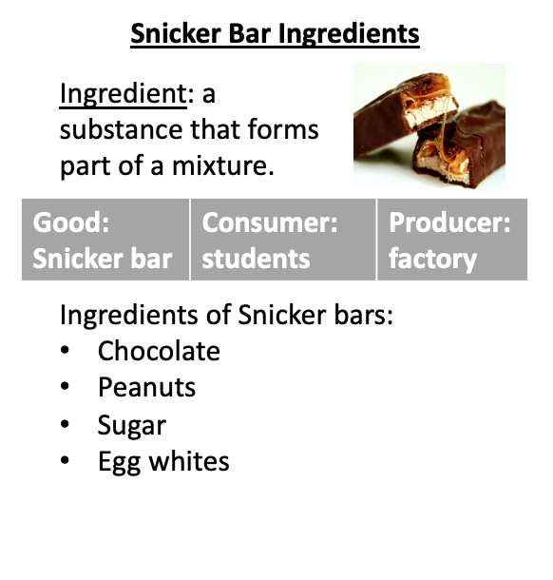
- Refer to this Graphic Organizer for each student for day 4.
- Social Studies Journal
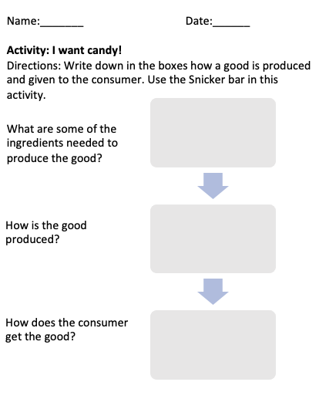
- Video: https://youtu.be/W3byiETFwZk?si=iSpbylzBGKRf0j6e
- Supply and Demand group work
  - 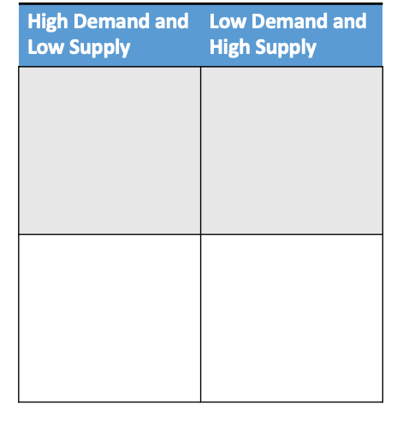
  - 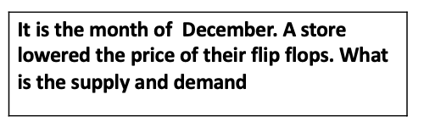
  - Example of a table and supply and demand card for a group
- Plickers Quiz https://www.plickers.com/set/65f1e311e1dd6f9074556e8d
  - iPad or Apple device with a working camera
  - Plickers cards for each student
*Suggested pacing is provided for each part - individual student/classroom needs may differ*

Days 7-9: Saving/Spending and Wants/Needs By Miss Leah Silverman
UNIT Learning Goals A learning goal describes what students should be able to DO by the end of the unit.
- Students will be able to understand what it means and how to save money.
- Students will be able to know what it means to spend money.
Essential Question(s) Students should be able to answer these questions by the end of the lesson to demonstrate their conceptual understanding of new concepts.
- What is most important to spend money on?
- Why is it important to understand saving?
- How can I save money?

FL State Academic Standards
SS. Benchmarks
SS.2.E.1.4 | Explain the personal benefits and costs involved in saving and spending.

B.E.S.T. ELA Connections
ELA.2.V.1.1 | Use grade-level academic vocabulary appropriately in speaking and writing.
ELA.2.C.1.1 | Demonstrate legible printing skills.

Options for Assessment
Assessment(s)
- Teacher Observation - Anecdotal notes
- Teacher Questioning -
  - What is something you would save up money to buy?
  - Can you give me examples of something you would spend money on?
  - Why is saving money important?
- Alternative Assessment
  - Vocabulary worksheet
Vocabulary
- Spending- To pay out or pay for
- Saving- Money that has been collected over time.
- Needs- Things we must have to live, such as food, clothes, and a place to live.
- Wants- Things we would like to have, but don't need to live.

Instructional Guide
Focus | Pacing* | Instructional Sequence
Preview/Motivate  Slide Deck  Group Discussion  YouTube Video  Read Aloud Books | 15 minutes  (5 minutes each day) | Before each day, ask introduction questions like:  - What is saving?  - What is spending?  Lead a class discussion on what money is and go over the vocabulary each day. In the class discussion, discuss saving for something special, like a toy or a bike. Also saving for emergencies, like when something unexpected happens.  Day 7- Video on saving/spending  Day 8- Read aloud Sally's Big Save by Laura Driscoll and illustrated by Amy Wumme  Day 9- Read Aloud  - A Penny in My Pocket  - By C M Harris and illustrated by Nareh Grigoryan  - read aloud
Vocabulary  Vocab Flashcards  Vocab Worksheet | 15 minutes  (5 minutes each day) | Introduce the key vocabulary terms for the next 3 days: saving, spending, needs, and wants.  Day 7- On day one we would just have a classroom discussion on each word and its definition. Ask students if they think they know what the word is if they have ever seen these words before, and how they are different from each other.  Day 8- On day two, have students work with a partner on the online flashcards. Have them first look over each flashcard. Then have them test each other.  Day 9- On day three, pass out the vocabulary worksheet to each student and do it individually. Students will glue the worksheet in their social studies journal. The worksheet includes each word, and the students would write the definition
Procedures  Class Money  Candy Activity  Financial Literacy Worksheet  YouTube Video | 45 Minutes  (15 minutes each day) | Day 7- Review….  To start work on day 7, introduce the whole class to the new class store. There will be three levels of goods that they can buy ($1, $5, & $10). In this introduction, use the vocabulary words heavily. We would have an open discussion about the three different price points and how the goods differ in each category. Ask questions like:  - If I were to buy an item from the store would that be spending or saving?  - If I didn't buy anything today, to buy something bigger another day what would that be?  To finish off day one, have the students cut and color the$1- and 5-dollar bills.  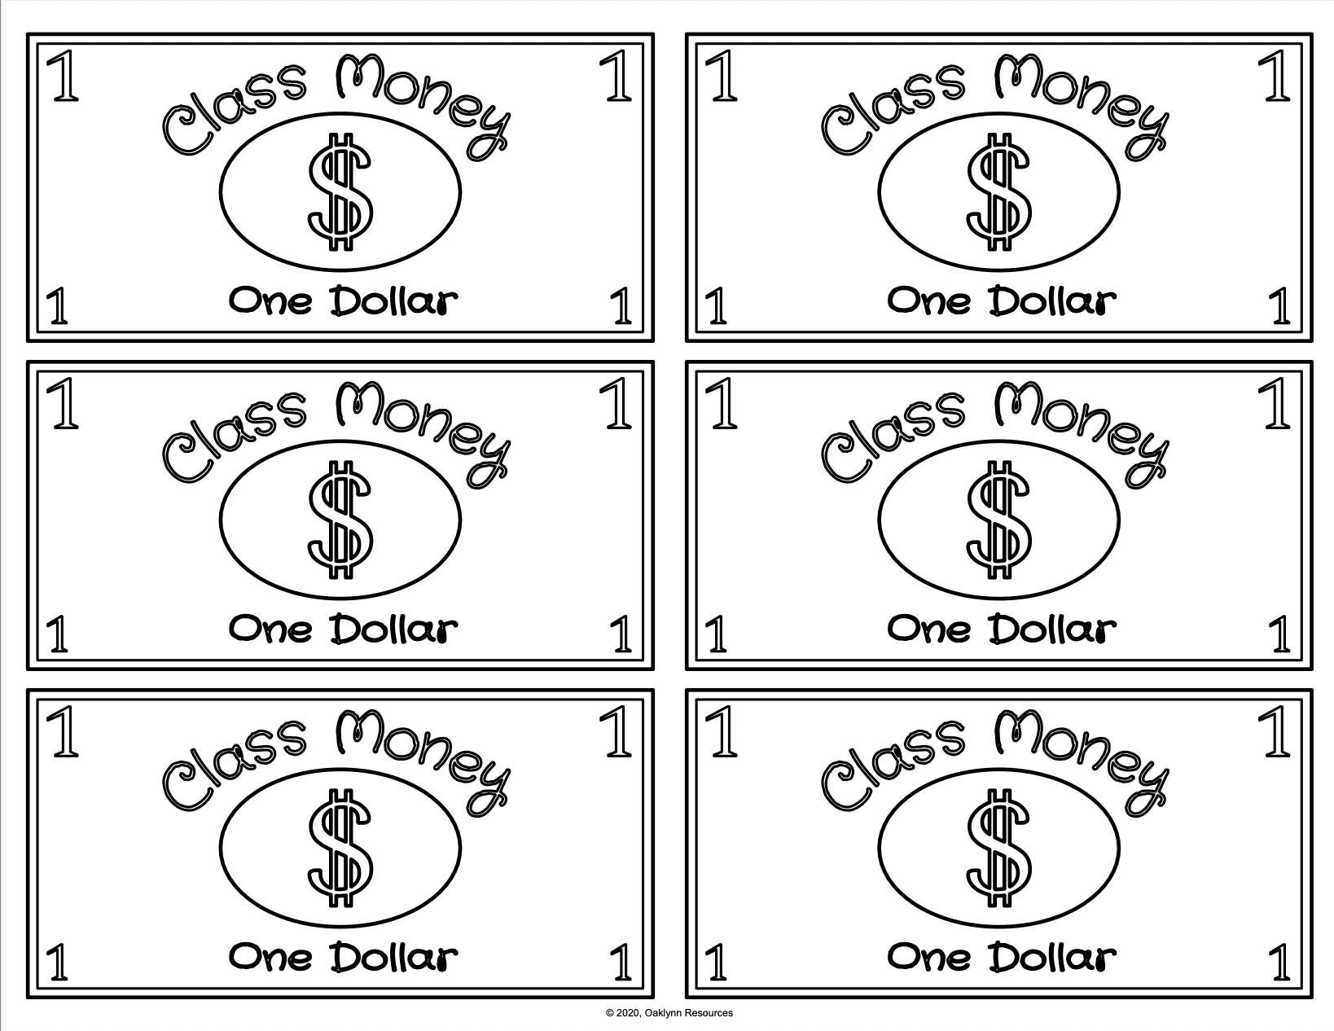  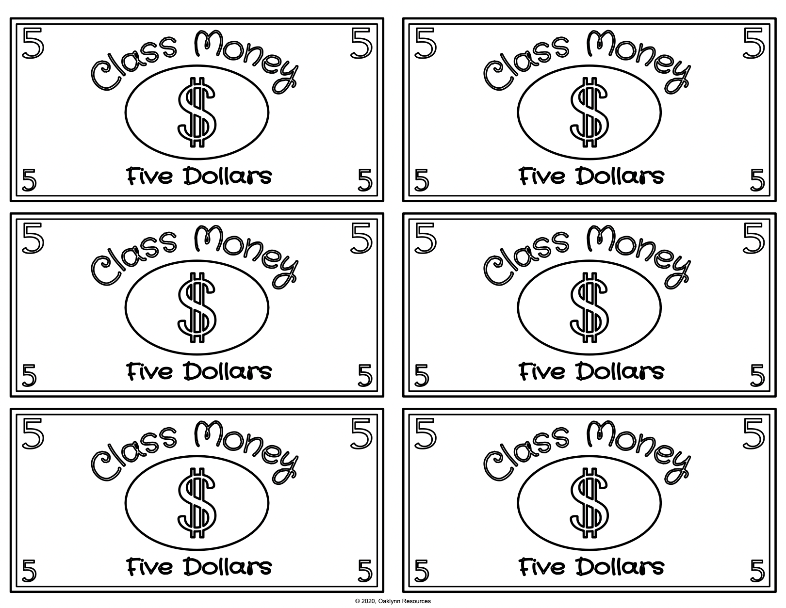  Share with the class that this is just an introduction to the class that is starting next week.  Day 8- Pass out one $5 bill to everyone. Then move on to the candy activity.  - For the activity, demonstrate how to only use money once. Put two M&M's on each desk. Then tell the students that each M&M equals a dollar. As a class, everyone would spend $1 (eat one candy) and save $1(not eat the candy). We would then look at how we can never get that dollar back since it has been spent. However, we still have dollars (M&M’s) we saved.  Day 9- Students would work in partners to complete their final literacy worksheet. Students will glue the worksheet in their social studies journal. They would read the passage to each other and then work on the questions. This worksheet highlights the vocab that they mastered before.  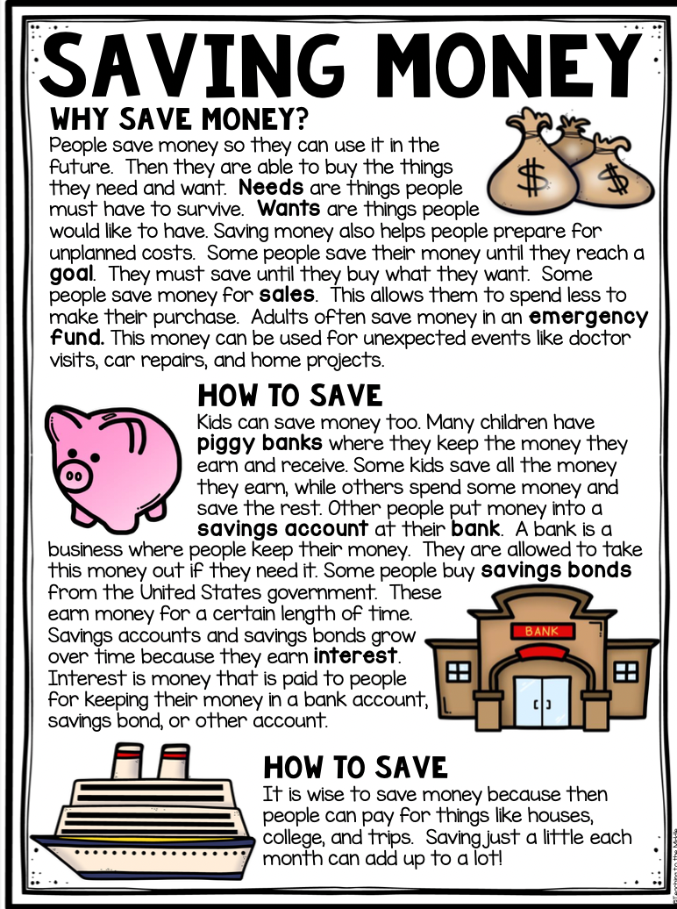  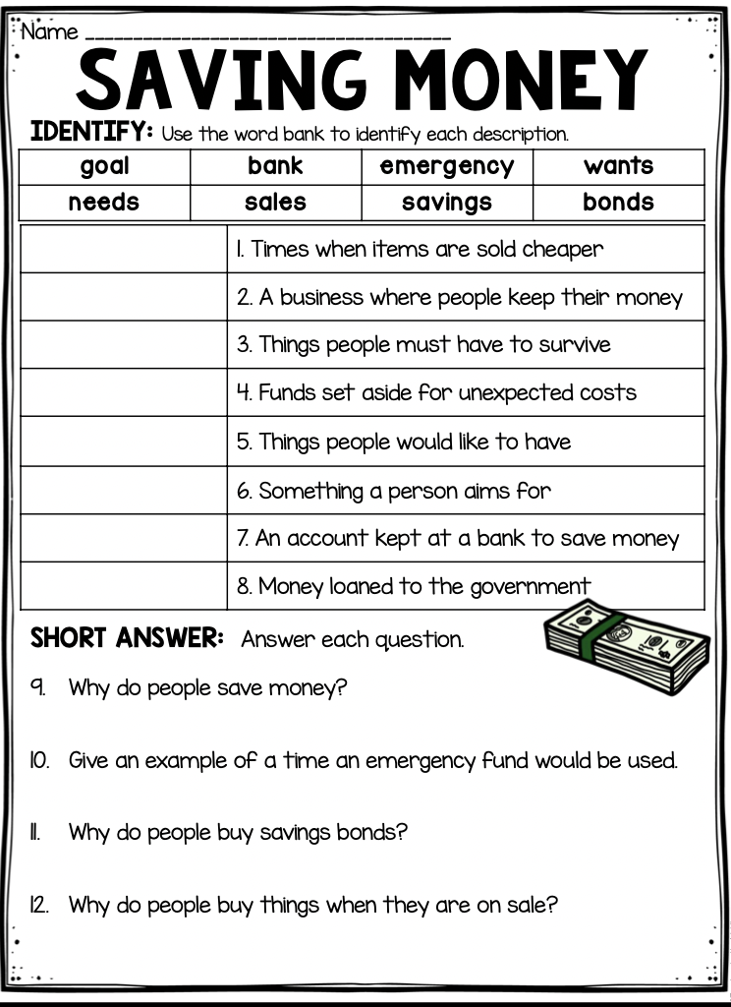  Once the worksheet is completed, play this YouTube video/song that focuses on earning, saving, spending, and donating money
Closure  Worksheet  YouTube Sort  Kahoot | 15 minutes  (5 minutes each day) | Day 7- Students will complete their spending and earning money worksheet. Students will glue the worksheet in their social studies journal:  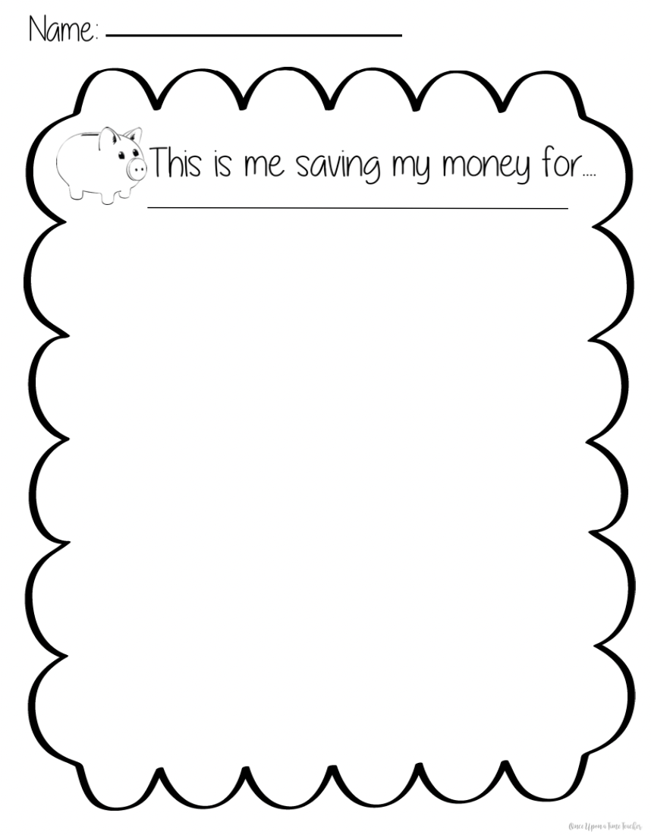  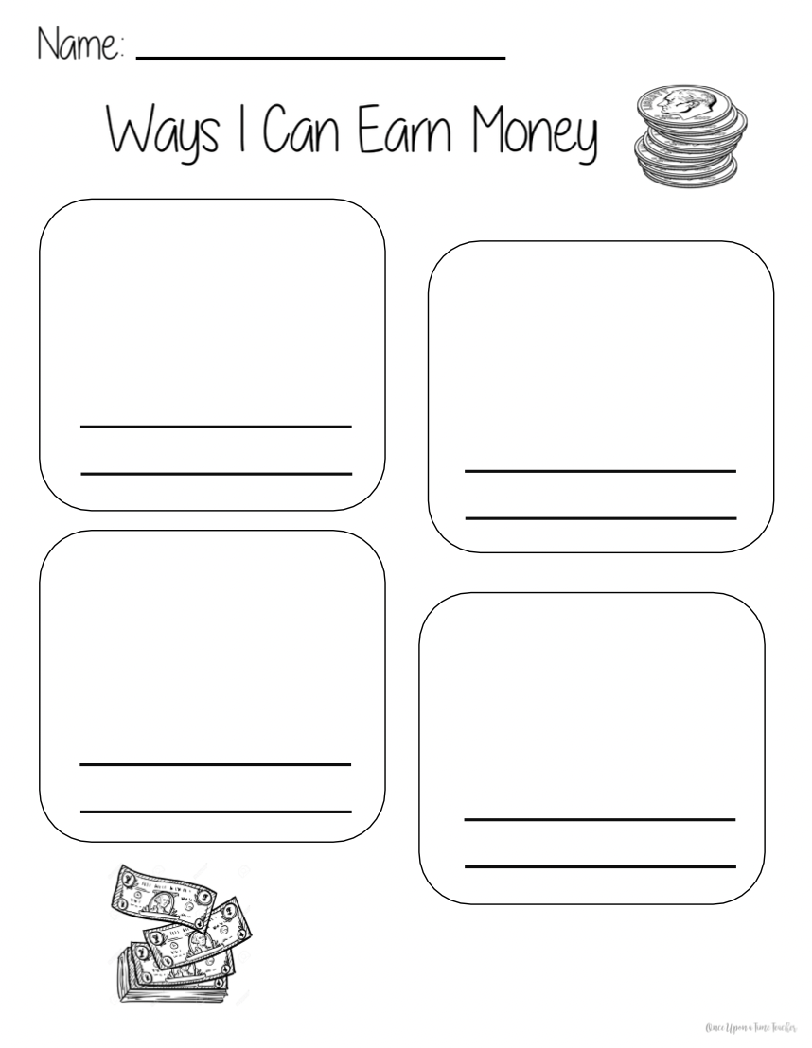  Day 8- Students will watch, follow along, and play this wants and needs sorting game/video  https://www.youtube.com/watch?v=9E2Myy58O04  Day 9- Students will complete Needs, Wants, Spending, and Saving Kahoot independently.
Remediation | 20 minutes  (Daily - based on need TBD) | Do remediation in small groups or one-on-one based on the student's needs. Hold the extra practice during ELA centers or individual work. During that time, help the students through extra books, worksheets, discussion, drawing, and writing assignments.

Closure
To conclude the three days, review each student's social studies journal worksheets and their Kahoot scores from Day 9 wrap-up activity. This Kahoot along with the worksheets, and anecdotal notes will act as my assessment for the three days.

Materials
- Computer
- Slide Deck- Presentation
- Sally's Big Save
- The book A Penny In My Pocket
- Vocabulary Flashcards- flashcards
- Vocabulary Worksheet- Worksheet
- Class Money template- money
- Some form of candy (M&M’s, Skittles)
- Worksheet- worksheet
- YouTube Video- Video
- Worksheet- worksheet
- YouTube Video Sort game
- Kahoot- Kahoot
*Suggested pacing is provided for each part - individual student/classroom needs may differ*

Days 10-12: Understanding Needs Vs Wants, The Importance of Saving Money, and Making Smart Spending Choices by Miss Mya Buck
UNIT Learning Goals A learning goal describes what students should be able to DO by the end of the unit.
- Students will be able to identify ways to save money.
- Students will be able to distinguish between wants and needs and understand the importance of making thoughtful spending choices.
Essential Question(s) Students should be able to answer these questions by the end of the lesson to demonstrate their conceptual understanding of new concepts.
- What is the difference between wants and needs?
- Why is it important to save money?
- How can we make smart decisions about spending money?

FL State Academic Standards
SS. Benchmarks
SS.2.E.1.1 | Recognize that people make choices because of limited resources.
SS.2.E.1.4 | Explain the personal benefits and costs involved in saving and spending.

B.E.S.T. ELA Connections
ELA.2.C.1.1 | Demonstrate legible printing skills
ELA.2.V.1.1 | Use grade-level academic vocabulary appropriately in speaking and writing.

Options for Assessment
Assessment(s)
- Teacher Observation - Scan for Anecdotal note template.
- Teacher Questioning -
- Can you give me an example of something that is a need and something that is a want in your life?
- Why do you think it is important to save money instead of spending it all at once?
- What are some things you should consider before buying something you’re your money?
- Alternative Assessment- informally assess students' understanding throughout the lessons by observing their participation and engagement in activities. Review the completed worksheets to gauge comprehension.
Vocabulary
- Saving: Keeping some of your money instead of spending it all.
- Spending: Using money to buy goods or services.
- Needs: Things we must have to live, such as food, clothes, and a place to live.
- Wants: Things we would like to have, but don't need to live.
- Comparison: Looking at how things are alike and different.
- Income: The money a person receives for their work or from investments.
- Allowance: Money given regularly to a child by a parent.
- Discount: A reduction in price.
- Budget: A plan for spending and saving money.
- Decision: A choice made between different options.
- Emergency: An unexpected and often dangerous situation requiring immediate action.

Instructional Guide
Focus | Pacing* | Instructional Sequence
Preview/Motivate  Group Discussion  Turn and Talk | 15 minutes  (5 minutes each day) | Day 10:  - Begin by asking students what they think it means to save money.  - Discuss basic ideas of saving such as putting money aside for later instead of spending it all right away.  - Introduce the concept of needs vs. wants: Needs are things necessary for survival and daily life (food, water, shelter, etc.) Wants are things we desire but can live without.  Day 11:  - Ask students why they think it’s important to save money.  - Discuss reasons for saving money: -Saving for something special, like a toy or a book. -Saving for emergencies, like when something unexpected happens.  Day 12:  - Open-ended questions:  - What does "demand" mean when we talk about things we buy?  - If you were a store owner, how would you know what to stock in your store?
Vocabulary  Flash cardsslide show  Matching Worksheet  Formative assessment using Plickers | 15 minutes  (5 minutes each day) | - Introduce key vocabulary in the lesson with a Slideshow:  Saving, Spending, Needs, Wants, Comparison, Income, Allowance, Discount, Budget, Decision, Emergency  - Complete a worksheet matching the term to its definition. Students will glue the worksheet in their social studies journal.  - Review supply and demand understanding using Plickers.
Procedures  Slide Deck  Video  Interactive activity | 45 Minutes  (15 minutes each day) | Day 10: By the end of the lesson, students will be able to distinguish between needs and wants by sorting given items into appropriate categories and articulate their reasoning for their choices.  - Watch the needs and wants video. (Stop at 1:37)  - After watching the video, students participate in an interactive activity sorting needs and wants.  - Discuss each item as a class, allowing students to share their reasoning.  Day 11: By the end of the lesson, students will be able to analyze spending scenarios, differentiate between wants and needs, and make informed decisions about whether to spend or save their money.  Spending Scenarios  - Students will be presented with different scenarios where they must decide whether to spend their money on something they want or save it for something they need.  - Discuss each scenario as a class, allowing students to share their thoughts.  - Introduce classroom store.  Day 12: Deciding on their good for classroom store. Recap Supply and Demand Vocabulary.  - Students will be assigned their groups (4 groups of 5)  - Students will meet in their groups and start to discuss what good they think is in demand by the students in the classroom and agree on a price for their product.  - Students will decide on their goods and write the goods they will produce on an index card, their business name, and all their names.  - Collect all index cards
Wrap-Up  Classroom discussions  Turn and Talk | 15 minutes  (5 minutes each day) | - Review the main points of needs vs. wants.  - Ask students to give examples of needs and wants from their own lives.  - Emphasize that understanding needs and wants helps us make smart decisions about saving and spending money.  - Review the importance of saving money and the different ways they can start saving.  - Ask students to reflect on a time when they had to decide whether to spend or save money and what they learned from that experience.

Closure
Emphasize the importance of thinking carefully before spending money and the benefits of making smart financial choices.
Introduce the supply and demand (classroom store) activity to students. Explain how they will be their own business creators and create their own goods to meet the needs of their buyers. Read instructions for day 13.

Assessments:
Plickers
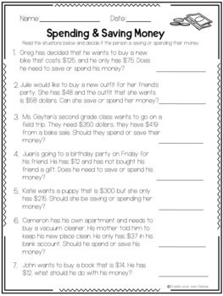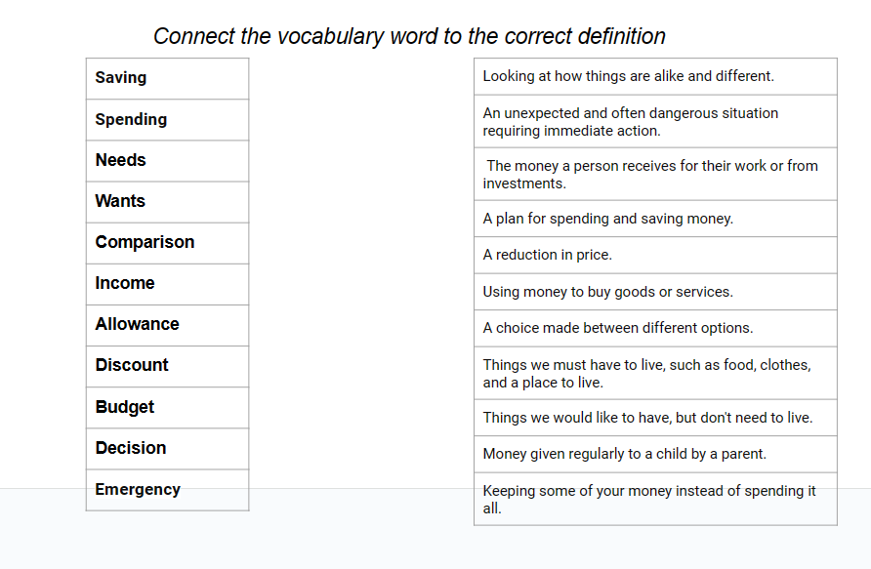

Materials
- Plickers
- Spending and saving Money worksheet PDF for closure activity
- Matching Worksheet
- Flash cards slide show
- Video
- Interactive activity
*Suggested pacing is provided for each part - individual student/classroom needs may differ*

Days 13-15: Creating TheOwn Business: Using Supply & Demand, Production of Goods, Classroom Store & Post Assessment by Miss Julia Buquicchio
UNIT Learning Goals A learning goal describes what students should be able to DO by the end of the unit.
- Students will be able to understand the importance of supply and demand when creating a product for consumers.
- Students will be able to budget their spending when buying products they want/need.
Essential Question(s) Students should be able to answer these questions by the end of the lesson to demonstrate their conceptual understanding of new concepts.
- What can we think about when creating a good for consumers?
- Why did the consumers buy more of one product?
- How was budgeting spending helpful when buying products?

FL State Academic Standards
SS. Benchmarks
SS.2.E.1.2 | Recognize that people supply goods and services based on consumer demands.
SS.2.E.1.4 | Explain the personal benefits and costs involved in saving and spending.

B.E.S.T. ELA Connections
ELA.2.V.1.3 | Identify and use context clues, word relationships, reference materials, and/or background knowledge to determine the meaning of unknown words.
ELA.2.V.1.1 | Use grade-level academic vocabulary appropriately in speaking and writing.

Options for Assessment
Assessment(s)
- Teacher Observation - Anecdotal notes sheet
- Teacher Questioning -
- How can we create goods based on the consumer's wants or needs?
- How can we budget spending when buying products?
- How can you sell a product to someone who may not want or need the product?
- Alternative Assessment- Informal assessment, walking around and listening to students' discussions when creating their goods and during headband vocabulary games. If students are struggling, ask guided questions to assist them get to their answer.
Vocabulary
- Review and assess all vocabulary from previous days
- supply, demand, goods, services, buyer, seller, price, market, production, saving, spending, needs, income, allowance, discount and budget

Instructional Guide
Focus | Pacing* | Instructional Sequence
Preview/Motivate  Read Aloud  Slide Deck (Slide 58)  Classroom Store  Slide Deck (Slides 60, 64 & 68) | 15 minutes  (5 minutes each day) | Day 13: Teacher read aloud - If You Give A Mouse A Cookie by Laura Joffe Numeroff  After the read aloud ask:  “What happened when the mouse noticed he needed or wanted something?”  “What do we need to think about when producing our own goods?”  As a class review these vocabulary words  “Why are wants and needs important when producing a good or service?”  Link for read aloud video resource available here and on the slide deck on slide 53  Day 14: The classroom will be set up when they get back from lunch as a classroom store. Review from yesterday: What did we do yesterday in groups? What do you think we will be doing today based on how the classroom looks? Ask students what they notice is different about the classroom and what they think we might be doing today.  Day 15: The classroom will be set up when they get back from lunch as a classroom store. Review from yesterday: What was your experience like during the classroom store? What did we do as consumers and sellers? Ask the students how their experience was yesterday with the store whether they were selling or buying.
Vocabulary  Slide Deck (Slides 59, 63 & 67) | 15 minutes  (5 minutes each day) | Using the vocabulary words students learned in the last 2 weeks, students will play a vocabulary headbands game in pairs.  Teacher Preparation-  - Prior to days 13-15 follow instructions here to make the headbands game.  - This website uses visuals and gives guided instructions on how to create these headbands. Just use this website for how to create the headbands.  - Then, either write down all the vocabulary on index cards: (supply, demand, goods, services, buyer, seller, price, market, production, saving, spending, needs, income, allowance, discount and budget) or print out these and cut them out.  - They will pair up so there should be a group of vocabulary word cards for each pair.  - Students will pair up with their table partners.  - Each pair will be given their vocabulary cards: supply, demand, goods, services, buyer, seller, price, market, production, saving, spending, needs, income, allowance, discount and budget  - Students will spend about 5 minutes each day doing 5 words a day. Every minute say “switch” and students will switch turns.  - Students will take turns putting an index card on their headband and the other student will have to describe the word using definitions and examples. The student wearing the headband will have to guess the vocabulary word.  - When both the students correctly guess their word, they will mark put them in a separated Ziplock bag labeled “mastered.” This way they don't repeat words. If they have extra time, they can revisit all the mastered words.
Procedures  Slide Deck (Slides 60-69) | 45 Minutes  (15 minutes each day) | Classroom Stores Activity  Day 13: Production of Goods  - Students will meet in their groups and begin to assemble their goods. They will need to produce at least 20 items to be prepared for their buyers.  - One student will oversee making a sign for their business advertising their product.  - The rest of the students will use paper and crayons to draw and cut out a picture of their chosen good, they need at least 20 but can make more if they have time.  - When time is up, they will put all their finished products in a plastic zip-lock bag. Teachers will label it with their business name in Sharpie.  Day 14: Buying and Selling Goods Day 1  Prior Set up: Four tables around the classroom, each table will have the business signs they created, their products laid out, and a box representing their cash register with fake money, 20 dollars in 5’s and singles for change.  - Each group will get $160 total to spend on other businesses goods. Explain how they will need to budget their money and think about what they really need or want to buy and look at everything before they purchase. (2 minutes)  - Students will get in their groups and decide which 3 students will start to sell their product and the other 2 will be buyers at other businesses for today, they will each get $40. (3 minutes)  - The first 3 students selling the products will go to their assigned table first and wait for their customers.  - I will set a timer on the board for 10 minutes and when I say go the buyers will go and buy their classmates goods.  - The students selling must give the customer the product, collect the money, and figure out how much change the customer needs (if any) with a calculator.  Day 15: Buying and Selling Goods Day 2  - Students will get in their groups and switch roles, if they were a seller on day 14, they will be a buyer today and vice versa. The buyers will each get $40 to spend.  - The first 3 students selling the products will go to their assigned table first and wait for their customers.  - I will set a timer on the board for 10 minutes and when I say go the students shopping will go and shop at the stores.  - The students selling must give the customer the product, collect the money, and figure out how much change the customer needs (if any).
Wrap-Up  Whole Group Discussions - Reflection Questions  Slide Deck (Slides 61 & 65)  Kahoot (Summative Assessment)  Slide Deck (Slide 69) | 15 minutes  (5 minutes each day) | Day 13:  Come back as a whole group to their desks and discuss anything their group struggled with and what they succeeded in when producing their product.  Reflection Questions:  What was something you and your group struggled with when producing your goods?  What was something your group succeeded in?  Is your product of good quality, will people be attracted to buy it?  Day 14:  Come back as a whole group and discuss how their groups came up with a product to reflect.  Reflection Questions:  What did you enjoy about your role today (buyer or seller)?  What was something that happened when buying or selling today that you did not expect?  What was one product you saw today that fulfills a need we have in this classroom as consumers?  Day 15: Teacher will go to this Kahoot link and log in. (Create an account before day 15)  - Click start and the game pin will appear on the board for students to see. Students will go to Kahoot.com on their electronic device (laptop, iPad, phone, etc.) They will put in the code or scan the QR code for this economics game. Once all students' names appear on the board, start the game.  - Teacher will monitor the game, read each question aloud and click next after each question is complete.  - Students will read each question on the board and click the color that corresponds to the answer they believe to be correct on their devices.  - These are the assessment Kahoot questions
Remediation | 20 minutes  (Daily - based on need TBD) | Remediation will be based on whole group discussions and if the students are really grasping the concepts and the reason we are doing this activity.  For students struggling: Take out their notes from previous days to review one one-on-one. Ask guiding questions. Assess their answers during the headband vocabulary games.

Closure
Remind students how important the process of supply and demand and saving and spending is and how they are all connected.
Explain how we thought about supply and demand when deciding on a product and how the buyers and the stores had to budget their spending when buying goods.
Summative Assessment: Kahoot
Formative Assessments: Headbands vocabulary review, whole group reflection wrap up questions

Materials
- If You Give A Mouse A Cookie, construction paper, index cards, stapler, rubber bands, headbands vocabulary/instructions guide, crayons, scissors, plastic Ziploc bags, 4 shoe boxes, fake money, calculators, Kahoot game
*Suggested pacing is provided for each part - individual student/classroom needs may differ*

Detailed Day 1 Lesson Plan:

Lesson Title & Anticipated Duration
- Day One: Shops, Shops, Shops! Goods and services that are here for me
- Lesson Duration: 30 minutes

Content Area
Economics

Grade Level
2nd

Unit Goals
- The students will understand the concept of supply and demand and recognize that people provide goods and services in response to societal needs and wants.

National Council for the Social Studies (NCSS) Theme(s)
- Production, Distribution, and Consumption

Daily Lesson Objective(s)
- When given a worksheet with 10 items, students can identify what items listed are goods and which ones are services. They should answer at least 7 items correctly.
- Students will apply addition and subtraction skills to solve real-world problems during the motivation activity.
- The students will hypothesize why people offer goods and services.
- Students will be able to apply grade-appropriate phonics and word analysis skills to decode unfamiliar words that will be part of the vocabulary for the unit.
- Students will demonstrate proficiency in legible printing skills, forming letters accurately and consistently during the whiteboard showdown.

Standards (Florida SS; BEST-ELA & Math)
- S.S.2.E.2.1 Recognize that people supply goods and services based on demands.
- ELA.2..F.1.3 Use knowledge of grade-appropriate phonics and word analysis skills to decode words.
- ELA.2.C.1.1 Demonstrate legible printing skills.
- MA.2.NSO: Add and subtract two- and three- digit whole numbers.

Assessment
- Daily/Formative/Progress Monitoring/Alternative Assessments(s)
  - Pictures will be shown on the board that represent goods and services and students should answer as many of them properly.
- Teacher Observation
  - Progress Monitoring rubric.

- Teacher Questioning
  - Can you explain what a service is in your own words?
  - Why do you think people provide goods and services in a community? Do you think they are necessary? Why or why not?
  - What is a service that someone in your family provides for you?
  - Why is it important for businesses to provide goods and services?

Access Prior Knowledge (Evidence-Based Practices)
- These concepts should be demonstrated during the motivation activity:
  - Familiarity with the roles of buyers and sellers in a marketplace setting.
  - Understanding of negotiation and decision-making processes.
  - Recognition of the exchange of goods and services for money.
  - Awareness of what tangible and intangible things are.
  - Ability to reflect on observations and experiences.

Procedures
- Motivating Activity UDL 8.3 - First make sure to have a picture of a busy city street with shops on the board and ask students what they see. UDL 8.3- Foster collaboration and community.
- The next activity can be done with the whole class, or you could ask 4-8 volunteers to help you and should take no more than 10 minutes. EL 2- Promote collaboration. The money used should be whatever currency the classroom has.
  - Setup: Arrange the classroom to resemble a marketplace with different stations representing various goods and services. You can use tables or desks to display items such as toys, books, snacks, and art supplies. Designate areas for services like haircuts, face painting, or storytelling.
  - Assign Roles: Assign each student a role as either a buyer or a seller. Encourage creativity by letting them choose or invent their own characters, such as a toy shop owner, a baker, or a customer looking for a special gift.
  - Introduction: Start by explaining the concept of supply and demand in simple terms. Emphasize that buyers want to buy goods and services, while sellers provide those goods and services in exchange for money UDL 9.1- Promote expectations and beliefs that optimize motivation.
  - Role-Play: Let the role-play begin! Allow students to explore the marketplace, buying and selling items or services. Encourage them to negotiate prices, consider supply and demand, and make decisions about what to buy or sell.
- After the activity, students should reflect-UDL 9.3 on what they just saw. (5-7 min). UDL 3.2 Highlight patterns, critical features, big ideas, and relationships. Teacher questions:
  - What did you see?
  - Who was selling and who was buying?
  - What was being sold and bought?
  - Was everything that kids bought tangible? In this part, some students may not know what tangible means so just explain to them that tangible things are things you can see and touch.
- Start introducing the vocabulary and play the video. This video is EL and UDL compliant and will also help Thomas because the bouncing ball shows exactly what word is being sung.
- Have students sing the song with you a couple of times and then ask them to show you with their thumbs how confident they feel about understanding the words they have just learned.
- Lastly, choose one of the two activities:
  - Option A → White Board Showdown UDL 4.1
    - Using the “Goods and Services in the Community” worksheet, pick five goods and five services and choose a picture to represent each one.
    - Show the students the pictures -UDL 5.1 and have them right down the answers on their whiteboards. Make sure to use simple speech and keep instructions short and simple -EL 14. If any students get an answer wrong, make sure you annotate their names -EL 6. Students should correctly answer 3/5 of the pictures of goods and services.
    - The short prompt will be easy for Thomas to follow. Both ELLs and Thomas will benefit from using pictures (visual cues) instead of just having the word up on the board.

  - Option B → Activity sheet
    - Distribute the Activity worksheet titled “Goods and Services in the Community”
    - Either read each prompt to the students and give them time to circle the correct answer before moving on to the text to guide them -EL 22, or have them read it on their own and walk around the classroom monitoring their work -UDL 7.1.
    - Students should answer at least 7/10 questions correctly.
    - Keep their worksheets so that you can identify how much students understand these new concepts -EL 6.

Closure
The closure activity will be the whiteboard showdown or Activity sheet, whichever one the teacher decides to use. If deemed necessary, the teacher can have students sing the “Goods and Services” song again.

Materials
- Progress Monitoring rubric.
- Goods and Services song.
- Is this a good or a service worksheet?
- Kahoot Post Test.
- White Board Showdown pictures:
- 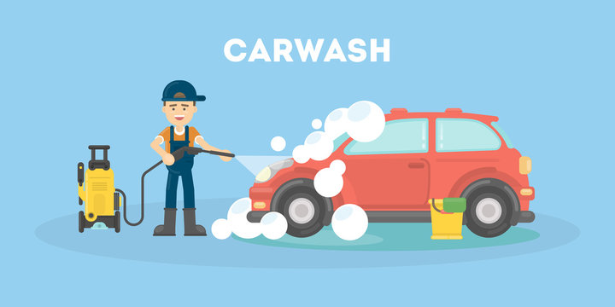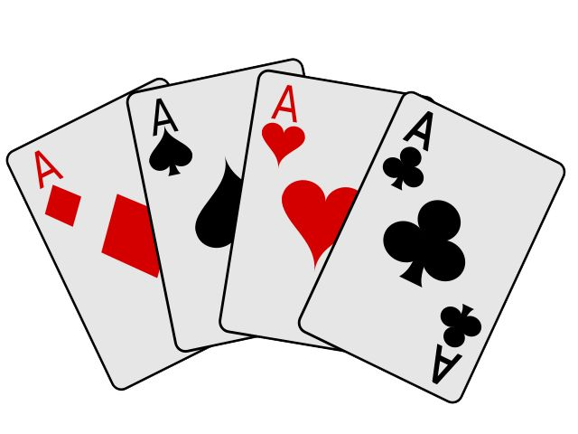

- 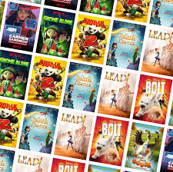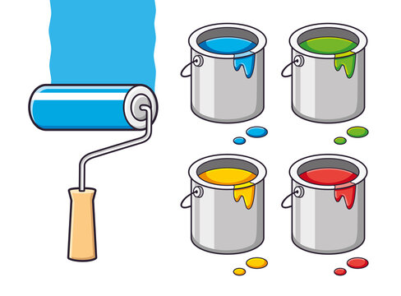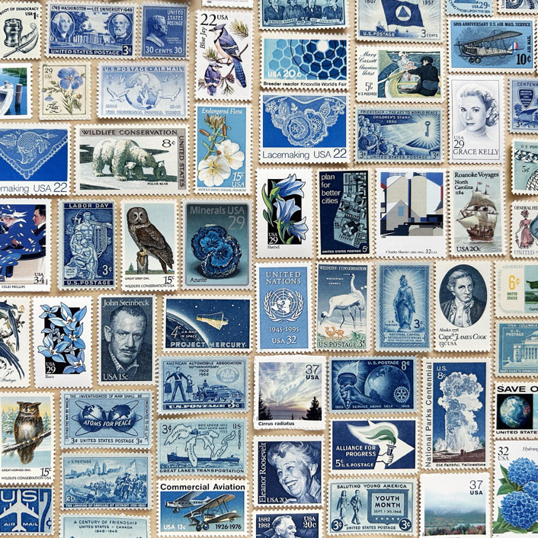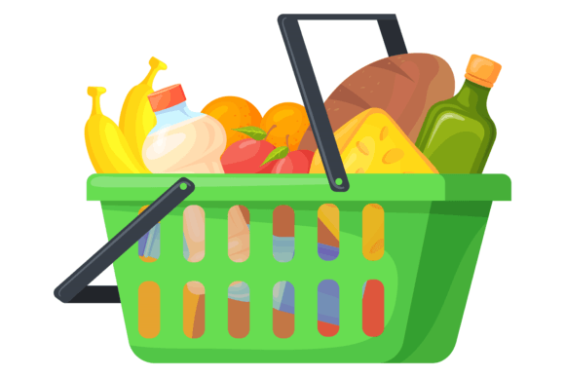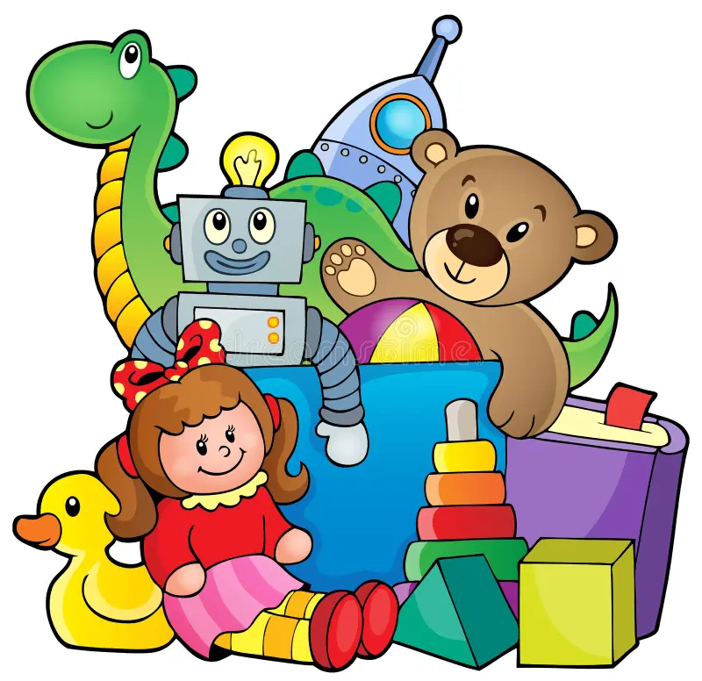

Post Assessment:
- Kahoot
  - Questions on the Kahoot:
    - When people buy goods and services, they are called…
      - Consumers
      - Producers
      - Scarcity
      - Resources
    - Which of the following is a producer?
      - Someone who BUYS cookies.
      - Someone who SELLS cookies.
      - A person who drives a truck
      - A doctor
    - Which of the following is an example of a service?
      - Books
      - Shoes
      - Food
      - Medical care
    - Which of the following is good?
      - Education
      - Medical care
      - Barber shops
      - Food
    - When a person sells a good, they are…
      - A teacher
      - A producer
      - A consumer
      - A truck driver
    - What is a need?
      - Something people would like to have.
      - Something people can’t live without
    - What is a want?
      - Something people would like to have.
      - Something people can’t live without
    - Saving money is important because it allows us to plan spending.
      - True
      - False

