# UCF PEGASUS PLAN - 1st Grade - Maps & Globes

Alejandra Vega, Lindsay Schultz, Anna Howell, Georgia De Los Santos, Gianna Astriab

## National Council for SS Themes:

|  |
| --- |
| People, Places, and Environments |
| Science, Technology, and Society |

## Social Studies Standards:

|  |  |
| --- | --- |
| [SS.1.G.1.4](https://www.cpalms.org/PreviewStandard/Preview/2916) | Identify a variety of physical features using a map and globe. |
| [SS.1.G.1.AP.2](https://www.fldoe.org/core/fileparse.php/20602/urlt/10-6.pdf) | Recognize key elements of maps and globes. |
| [SS. 1.G.1.3](https://www.cpalms.org/PreviewStandard/Preview/2915) | Construct a basic map using key elements including cardinal directions and map symbols. |

## B.E.S.T. Standards:

|  |  |
| --- | --- |
| [ELA.1.R.2.3](https://www.cpalms.org/PreviewStandard/Preview/14932) | Explain similarities and differences between information provided in visuals and words in an informational text. |
| [ELA.1.V.1.3](https://www.cpalms.org/PreviewStandard/Preview/14949) | Identify and use picture clues, context clues, word relationships, reference materials, and/or background knowledge to determine the meaning of unknown words. |

## Unit Goal:

|  |  |
| --- | --- |
| The student will | demonstrate his or her understanding of both map and globe characteristics. |

## Unit Scale:

|  |  |
| --- | --- |
| **4** …and can teach it. | I can create a map |
| **\*3** (Mastery) I can | Interpret various types of maps and globes, identify key features, and analyze spatial relationships between places. |
| **2** With support, | I can provide definitions for each of the map features as well as any geographical terms. |
| **1** …yet. | I am not fully aware of both map and globe features |

## UDL Principles: [UDL Website](https://sites.google.com/view/sse3312-teachsocialstudies/udl-el?authuser=0)

|  |
| --- |
| **UDL 9.2 Engagement - Self Regulation:** Facilitate personal coping skills and strategies. |
| **UDL 1.1 Representation - Perception:** Offer ways of customizing the display of information. |
| **UDL 6.3 Action & Expression - Executive Functions:** Facilitate managing information and resources. |
| **UDL 6.1 Action & Expression - Executive Functions:** Guide appropriate goal setting. |

## ESOL Strategies: [ESOL Resources](https://sites.google.com/view/sse3312-teachsocialstudies/udl-el)

|  |
| --- |
| **ESOL 34:** De-emphasize speed and emphasize accuracy of work |
| **ESOL 17:** Provide contextual support through audio visuals, models, demonstrations, realia, body language and facial expressions |
| **ESOL 23:** Structure advance organizers consisting for new terminology that learners will encounter in the new lesson vocabulary to be reviewed |

## Technology: [ISTE Standards for Teachers](https://www.iste.org/standards/for-educators)

|  |
| --- |
| **2.2.b Advocate for Equitable Access:** Advocate for equitable access to educational technology, digital content and learning opportunities to meet the diverse needs of all students. |
| **2.5.a Accommodate Learner Differences:** Use technology to create, adapt and personalize learning experiences that foster independent learning and accommodate learner differences and needs. |
| **2.7.c Use Data to Guide Progress:** Use assessment data to guide progress and communicate with students, parents, and education stakeholders to build student self-direction. |

## Unit Outline:

|  |  |
| --- | --- |
| Day 1: | View the Detailed Day One Lesson Plan  Understanding Maps  Introduction to the concept of maps and their purpose. |
| Day 2: | Parts of a Map  Key elements of a map will be covered (e.g., title, compass rose, legend/key, scale).  Students will identify the elements on sample maps.  Students will also engage in a group activity where they create a simple map of their classroom. |
| Day 3: | Parts of a Map (Continuation of Day 2) |
| Day 4: | Cardinal Directions  Cardinal directions (north, south, east, west) will be introduced using a compass rose.  Students will practice identifying cardinal directions in the classroom and on a map.  Students will also play a game or do a scavenger hunt using cardinal directions. |
| Day 5: | Map Symbols  Introduce common map symbols (e.g., house for a residence, tree for a park)  Review and Assessment  Review concepts learned throughout the week |
| Day 6: | Recap  Identify key features of maps  Introduction to Globes  Introduce the concept of a globe as a three-dimensional representation of the Earth |
| Day 7: | Comparing Maps and Globes  Discuss similarities and differences between maps and globes.  Complete a T-chart comparing the two. |
| Day 8: | Comparing Maps and Globes (continuation) |
| Day 9: | Using Globes for Directions  Practice using the globe to determine directions. |
| Day 10: | Review and Assessment  Review concepts learned about globes. |
| Day 11: | Map Scavenger Hunt  Conduct a scavenger hunt activity where students use maps to find specific locations or answer questions. |
| Day 12: | “Mapping Penny’s World” by Loreen Leedy.  Students read Mapping Penny’s World which tells Penny’s life and community through maps. |
| Day 13: | Story Maps  Students are creating their own map that shows their route for a trip they went to recently. |
| Day 14: | Reflection and Review  Reflect on the unit as a whole and discuss what students have learned. |
| Day 15: | Review and Post Assessment  Administer a final assessment covering both maps and globes. |

## Unit Plan: Grade 1 - Maps & Globes - *Geography*

| Days 1-3: Parts of a Map |
| --- |
| **UNIT Learning Goals** *A learning goal describes what students should be able to DO by the end of the unit.* |
| * Students will be able to understand the concept of maps and know the purpose of a map. * Students will be able to identify elements of a map. |
| **Essential Question(s)** *Students should be able to answer these questions by the end of the lesson to demonstrate their conceptual understanding of new concepts.* |
| * *What can we use a map for?* * *Why did we look at our classroom like we were birds or butterflies?* * *How were map keys used to help illustrate what is on the maps?* |

|  |  |
| --- | --- |
| **FL State Academic Standards**  **SS. Benchmarks** |  |
| **SS.1.G.2** | Identify key elements of a map (compass rose, cardinal directions, title, key/legend with symbols) of maps and globes. |
| **SS.1.G.3** | Construct a basic map of bedroom, classroom, or route to school. |

|  |  |
| --- | --- |
| **B.E.S.T. ELA Connections** |  |
| **ELA.K.F.1.1**  **ELA.K.F.1.1 (g)** | Demonstrate knowledge of the basic concepts of print.  Recognize that print conveys specific meaning and pictures may support meaning. |
| **ELA.1.R.1.1** | Identify and describe the main story elements in a story |
| **ELA.1.R.2.1** | Use text features including title, headings, captions, graphs, maps, glossaries, and/or illustrations to demonstrate understanding of texts. |

|  |
| --- |
| **Options for Assessment** |
| **Assessment(s)**   * **Teacher Observation -** Walk around the room and make sure students are on track. Mark students down a private sheet of paper one to five. One is that they really need help, and five is that they fully understand the content. Routinely check in with students and ask them to show thumbs up or down on how they are feeling about their learning. * **Teacher Questioning –**    + *Can my students explain the purpose of a map?*   + *Can my students identify the main elements of a map?*   + *Can my students construct a basic map as a team?* * **Alternative Assessment** - [Alternative assessment is through Quizizz](https://quizizz.com/admin/quiz/568e669a9ddf8f0c68639d80?source=quiz_share). |
| **Vocabulary** |
| * map * map key * continents * symbols * location * map skills * spatial thinking * aerial view |

|  |  |  |
| --- | --- | --- |
| **Instructional Guide** |  |  |
| **Focus** | **Pacing\*** | **Instructional Sequence** |
| **Preview/Motivate**  Day One Lesson Plan  [Slide Deck](https://docs.google.com/presentation/d/1hpq_eD7cH-SkGutEF3EQsyJ5ErPBAZ5kIUL3rWy_tg4/edit?usp=sharing)  Classroom Activity | 15 minutes  (5 minutes each day) | 1. Slides 1 and 2: Introduce Map & Globe unit. Explain they will be learning the elements of a map along with locations on a map in their community and in the world. 2. Introduce [The Map Song](https://www.youtube.com/watch?v=v63Ygpl9xeM); encourage students to sing along. 3. Slide 3: Using the third slide, introduce the meaning of the word map. 4. In pairs, have students discuss their observations of the different maps. Ask or post discussion questions on the board:  * *What do you notice about these maps?* * *Are there differences?* * *What do you think the colors mean?*  1. Come back as a class and listen to students' responses. Enlarge the maps and be sure to point to the different features as students talk. 2. Ask: *Do you know what any of these maps are called?* 3. [Explain](https://www.youtube.com/watch?v=JXjn8kJDxY0) topographic, political, weather, and physical maps. 4. After this, pass out the maps worksheet. 5. Have students, to the best of their abilities, match the maps to their type. Tell students that there are clues from what they pointed out. |
| **Vocabulary** | 15 minutes  (5 minutes each day) | Develop key vocabulary. Introduce key terms: map, map key, compass rose, and location.   1. Introduce the vocabulary words in the lesson. 2. Open the website [Spelling City](https://www.spellingcity.com/) and type the words map, map key, compass rose, and location into step 1. Then, choose the Vocabulary game. Play this game to check for students' understanding of key terms. |
| **Procedures** | 45 Minutes  (15 minutes each day) | **Day 1 - Introduction to Maps, “Henry’s Map,” and “My Animal Farm”**   1. Slide 4: Continue to review the concept of maps. Ask:    * *Have you ever used a map?* *If so, for what purpose?*    * *Do you think maps are helpful/useful?*    * *How do you use a map?* 2. Use these [questions](https://first8studios.org/gracieandfriends/guide/spatial/lesson5/henrys-map-read-aloud.html) to help the reading of "Henry's Map" by David Elliot. 3. Pass out the [My Animal Farm](https://static.pbslearningmedia.org/media/media_files/c3dac3f0-15e0-435e-9c4b-1d6b27eac2ab/5bbb2995-a77b-46f6-82e4-6c2e06a62f11.pdf) activity. Be sure to pass it out upside down and have students keep it to the side for now. 4. Introduce "Henry's Map." Let students see the front, back, and the first couple of pages. Ask students to predict what might happen in the story. Tell students that the book is about a pig who decides to make a map of his farm (home). 5. Explain that they are going to construct a map just like Henry's and guide them through it on the board. 6. Open the book to the first page. Tell students to turn the worksheet over. Procedures for activity:    * Ask: *Where does Henry go first?* (the woolshed)    * *What symbol can be used to represent the woolshed?* Give students two options, and then have them raise their hands. The one with the most votes wins.    * Start the key on the board next to the teacher-led map. Write **woolshed** and then draw the symbol next to it.    * Explain what map keys and symbols are and why you are writing this down.    * Have students create their own key on the back of their map and copy the woodshed symbol.    * After drawing the symbol, place the woolshed in the top left, like the picture in the book.    * Repeat the steps with next sections of the book:      + Henry visits Abigail, a cow sitting underneath a tree. *What symbol should we use?* etc.      + The symbols should be Henry's house, the woolshed, the tree, the stables, and the chicken coop. 7. Make sure to spread out the drawings and then compare the teacher map to the map shown in the book. 8. Observe participation and engagement during the activity, check for comprehension as students complete their maps, review completed maps to assess understanding, and provide feedback and support. 9. After students have finished completing their maps, they will present them. Each component of their maps will be explained along with how their maps are somewhat like "Henry's Map" and how these created maps may be useful to students as they navigate to places outside of school. Ask:    * *Why did you create your map like this?*    * *Did you base your map off the book or base it off a map that you have seen before?*    * *How will these map components be beneficial to anybody using this map as a guide?* 10. Once all the students are done with presenting their work, they will reflect on what they enjoyed the most about completing this assignment.   **Days 2 & 3- Parts of a Map and Mapping the Classroom**   1. Review concepts of maps learned on Day 1.    * + Refer to “Henry’s Map” and allow children to turn and talk about map elements. Review Animal Farm activity sheet whole group. 2. Explain to students that they will be learning a little bit more about the different parts of maps. 3. Slide 5: Play the [BrainPOP video, "Parts of a Map."](https://www.youtube.com/watch?v=RdjdBJ8Xe2c&t=18s) Then ask:    * *How are things like a compass rose, key, etc., featured on maps?*    * *How can maps be different?*    * *Are there specific features on maps that are extremely important?* 4. Slide 5: Move to Mapping the Classroom. **\*Note:** Please see the [Mapping the Classroom](https://education.nationalgeographic.org/resource/mapping-the-classroom/) activity for even more in-depth instructions. 5. Before class, draw out the shape of the classroom on butcher paper. Then, cut out the shapes of furniture, doors, and rugs on construction paper. 6. Be sure to add the title of the map such as “Miss Howell’s Classroom Map” and add a compass rose and key. 7. In class, students stand in a circle and describe things in the classroom as "Next to," "Near," "Between," etc. 8. Explain that by doing this, they are describing the locations of things and that they will use similar language when creating their own map of the classroom. 9. Tell students that a map shows where things are located but also gives a bird's eye view of that place or what is called an aerial view. Ask:    * *What would a butterfly or bird see if they were flying above us?* 10. Take the basic map and ask:     * *What do you think these lines are?* (walls)     * *What are these openings?* (door, window) 11. Have students arrange the furniture, doors, etc. 12. Remind students that they are looking down and that it is a simple representation. Not everything in the classroom, like specific books, needs to be on the map, but they can add items to their maps. Have students draw things like desks and chairs or the classroom bookshelf. 13. Add to key as needed. 14. Make sure students are using the "Near to," "Next to," and "Between" language when students are adding to the map. 15. Have students practice using the classroom map. |
| **Wrap-Up** | 15 minutes  (5 minutes each day) | 1. Practice using the maps. From [Mapping the Classroom](https://education.nationalgeographic.org/resource/mapping-the-classroom/), ask students to show how they move around in the classroom by walking their fingers on the map from one place to another. For example, have a student walk her fingers on the map from the rug to where they sit at the table. Then, sticky notes with students' names should be placed in a few places on the map. Ask them to walk to that location. Other students can give them hints about where to go using the location words." 2. Hide things around the classroom while students close their eyes. Point to a location on the map where the treasure is hidden and have the students hunt for the treasure in groups.   **\*Note:** Please look at [Mapping the Classroom](https://education.nationalgeographic.org/resource/mapping-the-classroom/) for more detailed instructions. |
| **Remediation**  *\*This would happen during small group instruction at some other time during your day, possibly during ELA.* | 20 minutes  (Daily - based on need TBD) | In small groups, tell students they will be improving their own map of the classroom. Remind them of things like a map is a simple representation, that they are creating a map like they are birds or butterflies (from above). Compare the class led map and the small group maps. |

| **Closure** |
| --- |
| Close the day using this ten question [Quizizz assessment](https://quizizz.com/admin/quiz/568e669a9ddf8f0c68639d80?source=quiz_share). |

\**Suggested pacing is provided for each part - individual student/classroom needs may differ\**

|  |
| --- |
| **Materials** |
| * markers, pencils, etc. * butcher and construction paper * scissors * glue * whiteboard * [Maps and Globes Slide Deck](https://docs.google.com/presentation/d/1hpq_eD7cH-SkGutEF3EQsyJ5ErPBAZ5kIUL3rWy_tg4/edit?usp=sharing) * [The Map Song (PlayKids) YouTube Video (2:27)](https://www.youtube.com/watch?v=v63Ygpl9xeM) * [Henry’s Map](https://a.co/d/5dsYl3M), book by David Elliot * [PBS Map Skills Bingo PDF, Page 5](https://static.pbslearningmedia.org/media/media_files/c3dac3f0-15e0-435e-9c4b-1d6b27eac2ab/5bbb2995-a77b-46f6-82e4-6c2e06a62f11.pdf) * [BrainPop Jr Maps YouTube Video (5:39)](https://www.youtube.com/watch?v=RdjdBJ8Xe2c&t=18s) * National Geographic Learning Tool: [Mapping the Classroom Activity](https://education.nationalgeographic.org/resource/mapping-the-classroom/) * [Spelling City](https://www.spellingcity.com/) * [Quizizz](https://quizizz.com/admin/quiz/568e669a9ddf8f0c68639d80?source=quiz_share) * Matching Maps |

|  |
| --- |
| Days 4-6: Cardinal Directions, Map Symbols, & Globes |
| **UNIT Learning Goals** *A learning goal describes what students should be able to DO by the end of the unit.* |
| * Students will be able to examine cardinal directions with a compass rose. * Students will be able to identify map symbols on a globe. |
| **Essential Question(s)** *Students should be able to answer these questions by the end of the lesson to demonstrate their conceptual understanding of new concepts.* |
| * *What can a compass rose be used for?* * *Why did we explore our classroom using compasses?* * *How was learning the information about map symbols and compasses?* |

|  |  |
| --- | --- |
| **FL State Academic Standards**  **SS. Benchmarks** |  |
| **SS.1.G.1.2** | Identify key elements (compass rose, cardinal directions, title, key/legend with symbols) of maps and globes. |
| **SS.1.G.1.3** | Construct a basic map using key elements including cardinal directions and map symbols. |
| **SS.1.G.1.AP.2** | Recognize key elements of maps and globes. |
| **SS.1.G.1.AP.3** | Complete a pictorial map using symbols for designated areas. |

|  |  |
| --- | --- |
| **B.E.S.T. ELA Connections** |  |
| **ELA.K12.EE.2.1** | Read and comprehend grade-level complex texts proficiently. |
| **ELA.K12.EE.4.1** | Use appropriate collaborative techniques and active listening skills when engaging in discussions in a variety of situations. |

|  |
| --- |
| **Options for Assessment** |
| **Assessment(s)**  **Observation notes form for teachers**   * **Teacher Observation -**   **Note:** The area of language will be replaced with geography. Notes will be taken based on how efficiently students are able to complete required tasks that are included within each of the objectives for these three days.   * **Teacher Questioning –**    + *How well are students able to navigate to and from places with the use of cardinal directions?*   + *How well are students able to understand map symbols?*   + *How well are students able to comprehend the features of a globe?* * **Alternative Assessment**   **Maps and globes labeling worksheet** |
| **Vocabulary** |
| * cardinal directions * compass rose * direction * continent * ocean * globe * map symbol |

|  |  |  |
| --- | --- | --- |
| **Instructional Guide** |  |  |
| **Focus** | **Pacing\*** | **Instructional Sequence** |
| **Preview/Motivate** | 15 minutes  (5 minutes each day) | Before the instruction begins, students will be assessed to see what they already know. They will make believe that they are going somewhere and will have to explain the directions they will follow by using both map symbols and a compass.   1. Give students the option of either working in small groups or working individually. 2. The importance of map features will be explained to students. 3. Students will brainstorm thoughts on how map features may be very beneficial for them. They should be able to come up with at least three accurate ideas. 4. Along with maps, globes will be introduced briefly to students. Once students have taken enough time to examine the difference between both maps and globes, they will determine which is easier to use for navigating direction. 5. An introductory paragraph will be provided for the students to read. 6. Notes will be taken on how maps have played an important role in the everyday lives of human beings. |
| **Vocabulary** | 15 minutes  (5 minutes each day) | Important vocabulary terms will be introduced. These words are **cardinal directions, compass rose, direction, continent, ocean, globe, map symbol.**   1. Identifying vocabulary terms will be the first component of this lesson. 2. A handout consisting of each of the vocabulary words along with their definitions will be given to students as a reference. 3. When students are reviewing this handout, they will determine how these terms can be used in the context of relying on a map for assistance.   **\*Note: Each of these terms should be taught by utilizing a variety of vocabulary teaching methods according to students’ needs.\*** |
| **Procedures** | 45 Minutes  (15 minutes each day) | **Day 4- Introduce Map Symbols.**   1. Introductory details regarding map symbols will be explained in depth to students. 2. The lesson will begin with a brief discussion about common map symbols, these types of symbols being displayed on a map, and an interpretation of symbols. Students will then write down reasons as to why these three factors are important in regard to understanding maps. A set of questions will be provided for assistance as students are recording their responses. 3. A PowerPoint slide explaining ways in which map symbols may be used on a map will be available for students to view. 4. Show images of map symbols on a map and discuss which locations they are referring to. 5. Then, map symbols will be used to locate places that each of the students go to and from regularly. 6. A brief activity will take place for students to take part in. 7. This will be a group activity. Students will be provided with a map including symbols and discuss with each other how they can use these symbols to get to a place of their choice. 8. Each of the group members will record manually what they have discussed throughout the activity. 9. As the activity is taking place, I will approach each of the student groups. The locations in which students identify on their maps using the map symbols will need to be explained to me. 10. Comments are to be provided based on the locations that students identify as their primary to and from travel places. I may even award prizes to the groups that had identified the most places for traveling to and from on their maps.   **Day 5- Review and Assessment**  **Day 6- Introduction to Globes**   1. Basic facts about globes will be presented. 2. Images of both a flat map and a globe are to be shown. By examining these images, any advantages of utilizing a globe and a flat map will be communicated by students. 3. The next set of information to be covered is on continents and oceans. 4. Prior to verbally stating names of continents and oceans, students will list any names of these geographical features they already know. 5. A real globe will then be shared in class for students to see the names of each of the continents and oceans. 6. Once all students have gotten the chance to examine the globe, each student will be called on individually to explain which names of the continents and oceans they already knew and which names they had just learned from examining the globe. 7. Another group activity will be conducted. A set of questions will be displayed on the classroom’s whiteboard, and each of the group members will need to answer each of the questions as quickly as possible. 8. When students are finished with answering these questions, they will come up to me and show me the answers they had provided for each of the questions. 9. If students answered any questions incorrectly, they will keep attempting to correct their work until the timer goes off. |
| **Wrap-Up** | 15 minutes  (5 minutes each day) | * + - 1. Provide pairs or groups of students with index cards, each with a question pertaining to the topics covered these past three days.       2. Have students state the questions to one another and respond to them.       3. After pairs or groups discuss answers, discuss whole group.  1. Use student responses to identify student comprehension or misunderstandings. Use your observations to decide on potential individual or group remediation steps. |
| **Remediation** | 20 minutes  (Daily - based on need TBD) | 1. Give students a simple blank map of your school or community. 2. Have students draw small pictures of places that they frequently attend along with map symbols that may be used to accompany them as they travel to and from these places. 3. Use the map and globe to reteach or reinforce the major points covered during these previous three days. 4. Ask students to reflect and share answers for the question:    * + 1. *How important are map symbols for getting from one place to another?* |

|  |
| --- |
| **Closure** |
| Provide pairs or groups of students with index cards, each with a question pertaining to the topics covered these past three days. Use the pair, group, and class discussion to evaluate levels of student comprehension. |

|  |
| --- |
| **Materials** |
| * [Learning Cardinal Directions with a Compass Rose](https://florida.pbslearningmedia.org/resource/ll54-learning-cardinal-directions-video/lets-learn/) * Directions Dance Video * Map Symbols Video * Image of Vidsville Map with Map Symbols * Map with Symbols and Compass Rose * Globe |

\**Suggested pacing is provided for each part - individual student/classroom needs may differ\**

|  |
| --- |
| Days 7-9: Maps & Globes |
| **UNIT Learning Goals** *A learning goal describes what students should be able to DO by the end of the unit.* |
| * Students will be able to identify and locate continents and major oceans on a globe. * Students will be able to know the difference between maps and globes including similarities. |
| **Essential Question(s)** *Students should be able to answer these questions by the end of the lesson to demonstrate their conceptual understanding of new concepts.* |
| * *What are the differences between maps and globes?* * *Why are continents and oceans labeled on a globe?* * *How are maps similar to globes?* |

|  |  |
| --- | --- |
| **FL State Academic Standards**  **SS. Benchmarks** |  |
| **SS.1.G.1.4** | Identify a variety of physical features using a map and globe. |
| **SS.1.G.1.5** | Locate on maps and globes the student’s local community, Florida, the Atlantic Ocean, and the Gulf of Mexico |
| **SS.1.G.1.AP.5** | Locate Florida and a major body of water that borders Florida |

|  |  |
| --- | --- |
| **B.E.S.T. ELA Connections** |  |
| **ELA.K12.EE.4.1** | Use appropriate collaborative techniques and active listening skills when engaging in discussions in a variety of situations |
| **ELA.K12.EE.5.1** | Use the accepted rules governing a specific format to create quality work. |

|  |
| --- |
| **Options for Assessment** |
| **Assessment(s)**   * **Teacher Observation –** [Data Note Taking Sheet](http://lvargas08.blogspot.com/2012/11/anecdotal-notes_13.html?spref=pi) * **Teacher Questioning –**    + *What do globes help us understand?*   + *Why are there so many different types of maps?* * **Alternative Assessment** |
| **Vocabulary** |
| * map * globe * topographic map * physical map * weather map * political map * continents (North America, South America, Africa, Asia, Europe, Australia, Antarctica) * oceans (Indian, Atlantic, Pacific, Arctic) * compass * directions (North, East, South, West) |

|  |  |  |
| --- | --- | --- |
| **Instructional Guide** |  |  |
| **Focus** | **Pacing\*** | **Instructional Sequence** |
| **Preview/Motivate**  *A list of questions to ask can be found in the Quizizz online game (from days 4-6 materials) or any question the teacher can think of on the spot for review. | 15 minutes  (5 minutes each day) | *\*This game can be used all days before lesson content, just switch up the questions asked to stay relevant to what is being taught that day*\*  To review what content has already been taught up until this point a game will be implemented here. It’s called “Silent Speed [Globe](https://www.amazon.com/Squeezable-Tension-Reliver-Pattern-2pcs-63mm/dp/B09BFDFGF9?th=1).”   1. There is no talking! If someone talks, they are out. 2. All students stand up and move to the outside of their desks. 3. The teacher will hold a globe ball at the front of the classroom. 4. The teacher will gently toss a ball to a random student. 5. If the student catches the ball, they get to remain standing and answer the question the teacher gives them. However, if they drop or do not catch the ball they must sit down and are eliminated from the game. Also, if the student answers the question wrong, they must sit down. 6. This continues until there is one student left standing. They win!   **\*Note:** If any student talks at any point during this game they sit down. This game is to provoke quick response skills and healthy competition. |
| **Vocabulary** | 15 minutes  (5 minutes each day) | * Previous terms: *map*, globe, compass, direction, continent, and **ocean**. * New vocabulary terms based on continent: North America, South America. Europe, Africa, Asia, Australia, Antarctica * New vocabulary based on **ocean**: Atlantic, Pacific, Indian, Arctic * New vocabulary based on *map*: topographic map, physical map, weather map, and political map. |
| **Procedures**  **Day 7: Slides 14-16**  [10 Minute Timer: Rotating Earth YouTube Video](https://youtu.be/3LKRVtmympM?si=aXRtdWiygoePkg8i)  Assortment of Maps and Globes:*See Materials section.*  **Day 8: Slides 17-18**  [Merge Cube](https://docs.wixstatic.com/ugd/879cdc_2146ac3eac0045dcb440d715042de3bd.pdf) &  [Holo Globe App](https://apps.apple.com/in/app/merge-hologlobe/id1586658852)  [Continents and Oceans! Sing-Along (ABCmouse) YouTube Video](https://www.youtube.com/watch?v=gFIS3aLQPfs)  Globe Project  **Day 9: Slides 19-20**  [Continents and Oceans! Sing-Along (ABCmouse) YouTube Video](https://www.youtube.com/watch?v=gFIS3aLQPfs)  [Book: “Amelia’s Fantastic Flight”](https://a.co/d/7LqIE2J)  [Amelia’s Fantastic Flight, Read Aloud YouTube Video](https://www.youtube.com/watch?v=0arnV590_To)  [Continents Worksheet](https://www.whatarethe7continents.com/wp-content/uploads/2013/04/7-Continents-Map-Coloring-Example.png) | 45 Minutes  (15 minutes each day) | **Day 7: Map & Globe Stations**   1. Set up 3-4 different tables to hold different types of maps and globes. Use pictures of electronic resources if need be. 2. Have students get out a journal or piece of paper to record observations of the different objects on the tables. 3. Instruct the students to do a “gallery walk” around the room and observe all the objects. Encourage them not to linger too long at one table, but to make sure they see all objects. 4. Tell them to write down as many observations as they can about the objects on the tables. Tell them they will need these observations for the next assignment. Set a timer and give students 10 minutes, adjust the time according to their needs. 5. After the “gallery walk,” have students return to their seats and use their observations to fill out T-Chart of similarities and differences between the assortment of maps and globes they observed. 6. Draw the T-Chart on the board and model adding one similarity and one difference to the appropriate side of the chart. 7. If time allows, discuss whole group what similarities and differences they noticed.   **Day 8: Merge Cube Activity**  **Before the Merge Cube Activity:**   * Use the provided link to build a Merge Cube before the lesson or ensure there is a Merge Cube ready to use. * Download or make sure that the Holo Globe App on student devices/iPads.   **During Merge Cube Activity:**   1. Break the students up into small groups and give one iPad to each group. 2. Instruct them to open the Holo Globe App. 3. Have students click on the “World Map” picture and point their cameras toward the Merge Cube. 4. A world map in the form of a globe should appear. 5. Instruct students to find every continent one at a time. Guide students through this process.   *Note: The Merge Cube activity can be modified and adjusted wherever there is extra time/space throughout the unit. This activity can be added to “free time” or “quiet time” as well.  **After the Merge Cube Activity**   1. Slides 19-20: Play the Continent Song and encourage the kids to sing along with the lyrics at the bottom of the screen. If time allows, play two times.   **3D Globe Project Activity**   1. Slides 17-18: Pass out materials for the 3D Globe Project activity. **See additional files for 3D Globe Project PDF.** Model each step for the students and assist individuals when necessary. 2. Globe Project Procedures: 3. First, they need to label the continents and oceans in black marker. 4. Next, the students will color the continents in GREEN crayon and the oceans in BLUE crayon. 5. Have students color the base of the globe BROWN or GRAY. 6. Cut out the now colored and labeled parts of the globe.    * Instruct kids to cut all the way around as nicely as possible so they don’t cut off any major pieces of the globe or they don’t cut off the base of the globe. 7. Students should have 4 colored, labeled, and cut out pieces of a globe on a base. 8. Fold all 4 pieces on the dotted line (vertically down the center). 9. Take Base A and B, glue the blank backside of the right half of A to the blank backside of the left half of B. 10. Now take Base C, glue the blank backside of the right half of B to the blank backside of the left half of C. 11. Now take Base D, glue the blank backsides of Base D to the remaining sides of Bases A & C to finish your 3D globe.   **\*Note**: Students can keep this craft/model of the globe on their desk for the remainder of the unit to refer to.  **Day 9:**   1. Play [“Continent Song”](https://www.youtube.com/watch?v=gFIS3aLQPfs) for the class again to start this lesson off. Encourage the students to sing along to the lyrics at the bottom of the screen. 2. Next, read “Amelia’s Fantastic Flight” by Rose Bursik aloud to the class. Be sure to ask intermittent comprehension questions. If need be, watch a [read along](https://www.youtube.com/watch?v=0arnV590_To) of the book online. 3. Pass out the [Continent Worksheet](https://www.whatarethe7continents.com/wp-content/uploads/2013/04/7-Continents-Map.pdf) next. 4. Project the worksheet the whiteboard or via document camera. 5. Ask students to fill in what they know independently in pencil. Then have them share with a partner or group. 6. Then fill in the continent names whole group making sure to address any student errors and ensuring all student copies are labeled correctly. 7. Once all student maps are labeled correctly and completely, have students get out crayons. 8. Tell students you are going to give them instructions on which colors they will use for each continent but that it is going to be tricky. They will have to listen carefully and use the compass to help them. 9. Give students these directions verbally.  * Color in GREEN the continent **north** of South America.   *Answer: North America*   * Color in ORANGE the continent **east** Europe.   *Answer: Asia*   * Color in PURPLE the continent **south** of Europe.   *Answer: Africa*   * Color in RED the continent **south** of Asia and **north** of Antarctica.   *Answer: Australia*   * Color in BLUE the continent **west** of Africa.   *Answer: South America*   * Color in YELLOW the continent **north** of Africa and **west** of Asia.   *Answer: Europe*   * Color in BROWN the continent **south** of South America and Africa.   *Answer: Antarctica* |
| **Wrap-Up** | 15 minutes  (5 minutes each day) | To conclude, conduct a whole group review discussion. Ask questions like *Can anybody name the seven continents?* Once a student answers that question the teacher can review the continents from biggest to smallest.  **Example Questions:**   * *How many oceans are there on the globe?* * *Can you name all the oceans?* * *Why do we have different types of maps?* * *What was your favorite map to learn about and why?* * *How many different types of maps did we learn about?* * *If you could travel to any continent, which one would you choose?*   These are just some example questions to choose from to keep conversation flowing within the classroom and between the students. |
| **Remediation**  [Jamboard](https://jamboard.google.com/d/1-6t6ex5hBAyLh0m0fq9dgumWzEGcroaI1o2pyhHi9NE/edit?usp=sharing) | 20 minutes  (Daily - based on need TBD) | For remediation, open a Jamboard document ([Fig Jam](https://www.figma.com/figjam/) or [Padlet](https://padlet.com/) work as well) and have the students post one thing that they found the most interesting during this lesson, one thing they do not understand, and one thing they did not like. The students must then comment on two other students’ posts and say something positive or helpful to the discussion. |

|  |
| --- |
| **Closure** |
| The assessment for this content will be given on **Day 10** with the [Blooket](https://dashboard.blooket.com/set/6619739150e63c500725e8ba). This Blooket contains all the information that they have learned through days 7-9. The results the students have on Blooket will reveal to the teacher what content still needs to be learned or retaught. Teacher observation will show which students are struggling or need help with the content. |

|  |
| --- |
| **Materials** |
| * [10 Minute Timer: Rotating Earth and the Space Station](https://www.youtube.com/watch?v=3LKRVtmympM) * Assortment of different maps and globes: mini globe, colorful globe, world map, topographic map, physical map, weather map, political map (gallery walk) * Merge Cube   + HoloGlobe App * [Globe Ball](https://www.amazon.com/Squeezable-Tension-Reliver-Pattern-2pcs-63mm/dp/B09BFDFGF9?th=1) * ['Continents and Oceans!' 🌍 ABCmouse Sing-Along Music Video with Lyrics | Preschool and Kindergarten](https://www.youtube.com/watch?v=gFIS3aLQPfs) * 3D Globe Project Worksheets (see additional files for PDF)   + black marker   + green, blue, and brown (or gray) crayons   + scissors   + glue stick * [Amelia’s Fantastic Flight](https://a.co/d/bQx8gAO), book by Rose Bursik * [Seven Continent Coloring Worksheet](https://www.whatarethe7continents.com/wp-content/uploads/2013/04/7-Continents-Map.pdf) * [Blooket](https://dashboard.blooket.com/set/6619739150e63c500725e8ba) * [Jamboard](https://jamboard.google.com/d/1-6t6ex5hBAyLh0m0fq9dgumWzEGcroaI1o2pyhHi9NE/edit?usp=sharing) |

\**Suggested pacing is provided for each part - individual student/classroom needs may differ\**

|  |
| --- |
| Days 10-12: Map Scavenger Hunt & Penny’s World |
| **UNIT Learning Goals** *A learning goal describes what students should be able to DO by the end of the unit.* |
| * Students will be able to demonstrate the ability to recall key geographic terms related to maps and globes. * Students will be able to apply their understanding of maps and globes by using terminology and concepts to interpret and create maps. |
| **Essential Question(s)** *Students should be able to answer these questions by the end of the lesson to demonstrate their conceptual understanding of new concepts.* |
| * *What can maps and globes teach us about our world?* * *Why did we use a Blooket assessment to review our knowledge of maps and globes?* * *How was our class scavenger hunt using our constructed map helpful in applying our knowledge?* |

|  |  |
| --- | --- |
| **FL State Academic Standards**  **SS. Benchmarks** |  |
| **SS.1.G.1.2** | Identify key elements (compass rose, cardinal directions, title, key/legend with symbols) of maps and globes. |
| **SS.1.G.1.3** | Construct a basic map using key elements including cardinal directions and map symbols. |
| **SS.1.G.1.4** | Identify a variety of physical features using a map and globe. |

|  |  |
| --- | --- |
| **B.E.S.T. ELA Connections** |  |
| **ELA.K12.EE.3.1** | Make inferences to support comprehension. |
| **ELA.K12.EE.4.1** | Use appropriate collaborative techniques and active listening skills when engaging in discussions in a variety of situations. |

|  |
| --- |
| **Options for Assessment** |
| **Assessment(s)**   * **Teacher Observation –** *Anecdotal Notes* * **Teacher Questioning –**    + *What is the difference between a map and a globe?*   + *How are they similar?*   + *What parts of using maps or globes do you find most challenging?*   + *Why do you think it is important to know about maps and globes in everyday life?* * **Alternative Assessment –** A [13 question Quizizz](https://quizizz.com/admin/quiz/661f230d6c9f075db92bed4b/maps-globes?source=quiz_share) assessing knowledge on different maps and globe symbols and skills. |
| **Vocabulary** |
| * map symbol * direction * passport * pedometer * odometer |

|  |  |  |
| --- | --- | --- |
| **Instructional Guide** |  |  |
| **Focus** | **Pacing\*** | **Instructional Sequence** |
| **Preview/Motivate** | 15 minutes  (5 minutes each day) | **Day 10:** Indicate that students will be going over what they learned the previous week through a fun [Booklet](https://dashboard.blooket.com/set/6619739150e63c500725e8ba) game. This will be done individually if students have their own technological device, or in pairs/groups if there are not enough devices. Afterwards they will complete a [KWL](https://timvandevall.com/templates/kwl-chart-template/#google_vignette) chart.  **Day 11:** Introduce the slide of the day and let students know they will be working on a fun scavenger hunt using the map skills they have learned so far.  **Day 12:** Introduce students to the book they will promptly learn by showing students an image of the cover of the book. Ask them to make predictions as to what they think the book will be about.  **Guiding Questions:** *What do we see on the cover of the book? Who do we think Penny is?*  Afterwards they will be creating their own map inspired by what they have learned. (See procedures below) |
| **Vocabulary** | 15 minutes  (5 minutes each day) | Explain to students they will be learning new vocabulary words using index cards. Show an example of an already completed index card to demonstrate how they will be made.  **Create Index Cards:** Write each vocabulary word clearly on one side of an index card or sentence strip. Pronounce the word clearly and have students repeat to practice pronunciation. On the reverse the card, write a brief definition and draw a simple image related to the word.  In small groups or partners have students practice the vocabulary words by reviewing the definitions. Encourage them to quiz each other after reviewing at least three times and to use the index cards throughout the rest of the week when they cannot recall the meaning of a word. |
| **Procedures**  **Day 10**: Slides 21-22  [Blooket Link](https://dashboard.blooket.com/set/6619739150e63c500725e8ba)  [KWL Chart (Tim’s Printables Template)](https://timvandevall.com/templates/kwl-chart-template/#google_vignette)  **Day 11:** Slides 23-34  **Day 12:** Slide 35  [Mapping Penny’s World Read Aloud YouTube Video](https://youtu.be/vwlh7MmFwy0)  [Create a Map to Tell a Story | Crafts for Kids | PBS KIDS for Parents](https://www.pbs.org/parents/crafts-and-experiments/create-a-map-to-tell-a-story) | 45 Minutes  (15 minutes each day) | **Day 10:** Students will review the content they have learned so far on maps and globes through a fun review in Booklet. It is encouraged to take as much time as possible, make pauses in between questions if necessary and clarify any confusions students may have according to the results.  After the Blooket review, students will complete a KWL chart individually. Distribute the worksheet to each student and explain the purpose of it (What I know, What I Want to Know, What I Learned).   * Encourage students to reflect on what they have learned and what questions they still have about maps and globes. * Provide guidance to ESOL and ESE students in completing the chart.   **Day 11:** Ask students if they know what a scavenger hunt is, after students’ feedback explain and define the concept of a scavenger hunt. Organize students into groups to find 5 hidden items throughout the classroom.   * Students will need the classroom map they made during the first week (days 2 and 3) to successfully find these items. Address how they need to use the map skills they have learned.   Teacher will give mapping directions to instruct students where they can locate the items (one at a time) and display the slides throughout the scavenger hunt.  **Guiding Directions:**  **Item 1:** *"Travel to the west side of the classroom to find me, the most important travel document. Look north of the small group table and look.”*  **Item 2:** *"Travel east of our classroom library and you’ll find me, a representation of earth. Look north to the top of the shelf.”*  **Item 3:** *"Travel to the west of the classroom door and you will find me, a good tool to help find your way."*  **Item 4:** *“Travel south of the smartboard and find me, the transportation Amelia used to travel to the different continents."*  **Item 5:** *"Travel to the south side of the classroom and near the teacher’s desk is where you’ll find me. Use me to tell your friends and family how fun your travels have been."*  * Each time one student from the groups will go find the item until all are found, all students should get the opportunity to find the items.  **Day 12:** Conduct a read-aloud session of the book “Mapping Penny’s World” by Loreen Leedy.   * Read-aloud the book or play a read-aloud video if the book is not available. * Pause throughout the reading and ask comprehension questions and engage students in discussions.   **Discussion Questions:**   * *Who is Penny? What can be learned about her through maps?* * *What observations can be made from the book cover?* * *What role does Lisa play in the story, and how does she use maps?* * *Compare Lisa’s map to the classroom map used during the scavenger hunt. What similarities and differences do you notice?* * *What new things have you learned about maps from this book?* |
| **Wrap-Up** | 15 minutes  (5 minutes each day) | **Reflection Journals in Student Notebooks**  Instruct students to get their class notebooks where they will be creating a reflection journal.   * Encourage students to reflect on their learning, express their thoughts, and reinforce key concepts from the lesson. * Ask students to open their notebooks to a new page and title the page “Reflections on Maps and Globes.”   Provide prompts (below) for students to respond and circulate the classroom to aid and clarify any questions students may have.   * List one thing you found interesting or exciting about today’s lesson. * Write down one question you still have about maps and globes that you would like to learn more about.   **Drawing Accommodation (ESOL and ESE):**   * Encourage students to complete their written responses with drawings. * Allow for visual representation. |
| **Remediation** | 20 minutes  (Daily - based on need TBD) | **Guided Mapping Practice during Small Group Instruction**  Materials needed:   * Large paper or individual sheets * Drawing materials (colored pencils, crayons) * Visual aids (photographs or diagrams of classroom or playground)   Gather a small group of students and introduce the mapping activity by explaining they will be drawing a map of a familiar place, such as their classroom or the school's playground.   * Discuss key features that should be included on their map, such as desks, doors, windows, trees, and swings. * Be sure to encourage students to ask questions and clarify any details about the layout.   Distribute the materials and instruct students to start drawing their maps, making sure to incorporate the discussed key features.  **\*Note:** Once students have completed their maps, allow for a sharing session. |

|  |
| --- |
| **Closure** |
| As shown in slide 21, students will work on a [Booklet](https://dashboard.blooket.com/set/6619739150e63c500725e8ba) to review and discuss what they have learned so far. Address any remaining questions or areas of confusion and celebrate students’ achievements and progress. |

|  |
| --- |
| **Materials** |
| * Booklet: <https://dashboard.blooket.com/set/6619739150e63c500725e8ba> * Tablet/Laptop * [KWL Chart Template – Tim's Printables](https://timvandevall.com/templates/kwl-chart-template/#google_vignette) * Classroom map made on day 2 and 3 * Passport * Globe * Airplane * Compass * Postcard * [Mapping Penny's World](https://www.youtube.com/watch?v=hhZu0vs2FQA) * [Create a Map to Tell a Story | Crafts for Kids | PBS KIDS for Parents](https://www.pbs.org/parents/crafts-and-experiments/create-a-map-to-tell-a-story) * Crayons or colored pencils * Pencils |

\**Suggested pacing is provided for each part - individual student/classroom needs may differ\**

|  |
| --- |
| Days 13-15: Story Map, Reflection & Review |
| **UNIT Learning Goals** *A learning goal describes what students should be able to DO by the end of the unit.* |
| * Students will be able to discuss how maps are used to represent communities. * Students will be able to reflect on the unit as a whole and discuss what students have learned. |
| **Essential Question(s)** *Students should be able to answer these questions by the end of the lesson to demonstrate their conceptual understanding of new concepts.* |
| * *What can you tell me about maps and globes?* * *Why is the purpose of the map key?* * *How can you apply what you learned about maps/globes in the real world?* |

|  |  |
| --- | --- |
| **FL State Academic Standards**  **SS. Benchmarks** |  |
| **SS.1.G.1.2** | Identify key elements (compass rose, cardinal directions, title, key/legend with symbols) of maps and globes. |
| **SS.1.G.1.3** | Construct a basic map using key elements including cardinal directions and map symbols. |
| **SS.1.G.1.4** | Identify a variety of physical features using a map and globe. |
| **SS.1.G.1.AP.2** | Recognize key elements of maps and globes. |
| **SS.1.G.1.AP.3** | Complete a pictorial map using symbols for designated areas. |

|  |  |
| --- | --- |
| **B.E.S.T. ELA Connections** |  |
| **ELA.K12.EE.4.1** | Use appropriate collaborative techniques and active listening skills when engaging in discussions in a variety of situations. |
| **ELA.K12.EE.5.1** | Use the accepted rules governing a specific format to create quality work. |

|  |
| --- |
| **Options for Assessment** |
| **Assessment(s)**   * **Teacher Observation –** teacher observations using [anecdotal post-it notes](https://www.naeyc.org/resources/pubs/tyc/oct2019/practical-strategies-teachers) system. (Example) * **Teacher Questioning –**    + *What are map symbols and how can I use them?*   + *How can you apply what you’ve learned about maps into creating your own map?*   + *Why are maps so important in our lives?* * **Alternative Assessment -** [Blooket](https://dashboard.blooket.com/set/662065d1f0840c983cfa5522) |
| **Vocabulary** |
| * map * globe * topographic Map * physical Map * weather Map * political Map * continent (North America, South America, Africa, Asia, Europe, Australia, Antarctica) * oceans (Indian, Atlantic, Pacific, Arctic) * compass * cardinal directions (North, East, South, West) * compass rose * direction * continent * ocean * globe * map symbol * passport * pedometer * odometer |

|  |  |  |
| --- | --- | --- |
| **Instructional Guide** |  |  |
| **Focus** | **Pacing\*** | **Instructional Sequence** |
| **Preview/Motivate** | 15 minutes  (5 minutes each day) | **Day 13:** To start the lesson, students will answer a series of questions about the story they read previously. Then, students will listen to the read aloud again “Mapping Penny’s World” so the student remembers what happened. Students will get a chance to work with a partner when making their map or they can choose to work by themselves.  **Day 14:** This is a center activity. The groups are already chosen to avoid conflict and behavior issues. Each group will rotate every 15 minutes. Students can work as a group or by themselves but each person in the group has to turn something in.  **Day 15:** This is a review day. Students are answering questions on their laptop. This should be done individually. (As an incentive, whoever gets 100% will get a jolly rancher.) |
| **Vocabulary** | 15 minutes  (5 minutes each day) | The vocabulary list should be a review since we’re not introducing a new topic.  The vocabulary words should also be listed somewhere in the classroom so that the student can go back and forth when they forget something. |
| **Procedures**  **Day 13:** Slide 35  [Mapping Penny’s World Read Aloud YouTube Video (3:45)](https://www.youtube.com/watch?v=hhZu0vs2FQA)  [PBS Kids – Create a Map to Tell a Story](https://www.pbs.org/parents/crafts-and-experiments/create-a-map-to-tell-a-story)  **Day 14:** Slide 36  Center #1: [Continent pattern](https://patternuniverse.com/category/continents/)  Center #2: [Postcard around the world](https://pbskids.org/luna/games/lunas-postcards-around-the-world)  Center #3: [Reading a map](https://www.superteacherworksheets.com/maps/campground-map_WMZNM.pdf)  **Day 15:** Slide 37  [Quizalize Activity](https://app.quizalize.com/view/quiz/maps-186b6151-357b-4001-bcf5-3d714724ec3a) | 45 Minutes  (15 minutes each day) | **Day 13:** This day is the second part of Day 12. After reading “Mapping Penny’s World” students are creating their own map that shows their route for a trip they went to recently. First, students are to choose a trip they took whether it's local like going to their friend’s house or somewhere far away. Next, students are writing down what they observed on the trip such as:   * *What was the weather like?* * *What did they see, hear, smell?* * *How are they feeling while they are traveling?*   With the information the students listed, they will use the list to make their map. Include buildings, roads, streets, or towns they passed. Students are also required to make a map key that represents the symbols.  **Day 14:** This day is a center activity. There will be 3 centers. The teacher should start by introducing each center. The teacher should also model what the students are supposed to do so there is no confusion.  Center #1: [Continent pattern](https://patternuniverse.com/category/continents/)  Center #2: [Postcard around the world](https://pbskids.org/luna/games/lunas-postcards-around-the-world)  Center #3: [Reading a map](https://www.superteacherworksheets.com/maps/campground-map_WMZNM.pdf)  **Day 15:** This is a review/final assessment. Students are using their technology for this assessment. Students are using “Quizalize”, which is like Kahoot and Blooket mixed |
| **Wrap-Up** | 15 minutes  (5 minutes each day) | **Day 13:** To conclude, students are sharing their map with their peers and walking us through the map they created.  **Day 14:** To conclude, students will gather as a whole group discussing what they enjoy about the activity, what they didn't like, what’s difficult about it/ what’s the easy part about it, and what did they learn?  Then, turn and talk “*How can you apply what you learned about maps/globes in the real world?” “How can you use maps/globes in your daily life?”*  **Day 15:** To conclude, once the students are done with the quiz, the teacher is going over the questions that the student missed. |
| **Remediation** | 20 minutes  (Daily - based on need TBD) | Work with students who need additional support in small groups during centers. |

|  |
| --- |
| **Closure** |
| The assessments include:   * Creating a map (this shows students understand how to create and read maps using the terms that they learned) * Quizalize (this would shows the teacher if the students understand the topic) |

|  |
| --- |
| **Materials** |
| * Laptop/iPad * Headphones * [Mapping Penny’s World](https://www.youtube.com/watch?v=hhZu0vs2FQA) * [Blank Continent Patterns](https://patternuniverse.com/category/continents/) * Play Doh * Crayons * Pencil * [PBS Postcard](https://pbskids.org/luna/games/lunas-postcards-around-the-world) * [Reading a Map worksheet](https://www.superteacherworksheets.com/maps/campground-map_WMZNM.pdf) * [Quizalize](https://app.quizalize.com/view/quiz/maps-186b6151-357b-4001-bcf5-3d714724ec3a) |

\**Suggested pacing is provided for each part - individual student/classroom needs may differ\**

# Detailed Day 1 Lesson Plan:

**Lesson Title & Anticipated Duration**

|  |
| --- |
| * Day One: *Understanding Maps* * Lesson Duration: *30 minutes* |

**Content Area**

|  |
| --- |
| Geography |

**Grade Level**

|  |
| --- |
| Grade 1 |

**Unit Goals**

|  |
| --- |
| 1. The students will demonstrate an understanding of basic map and globe skills. 2. The students will apply these map and globe skills to activities that are assigned to them. |

**National Council for the Social Studies (NCSS) Theme(s)**

|  |
| --- |
| * People, Places, and Environments |

**Daily Lesson Objective(s)**

|  |
| --- |
| * The students will be able to communicate the overall purpose of maps as well as the concept of them. * The students will be able to examine a set of maps and determine the types of maps included in the set of maps. * The students will be able to communicate key concepts regarding maps found in a children’s book that they read. |

**Standards (Florida SS; BEST-ELA & Math)**

|  |
| --- |
| * SS.1.G.1.1 Use physical and political/cultural maps to locate places. * ELA.1.R.2.3 Explain similarities and differences between information provided in visuals and words in an informational text. * MA.1.GR.1.1 Identify, compare and sort two- and three-dimensional figures based on their defining attributes. |

**Assessment**

|  |
| --- |
| * **Pre & Post (Summative) Assessment**: * **Daily/Formative/Progress Monitoring/Alternative Assessments(s)**    + *A discussion session will be designed for students to participate in regarding a video on maps.*  1. *Notes will be taken by the teacher to assess how well students seem to convey information on maps among each other.*     * *Prior to communicating information about maps to the students, they will complete an introductory assessment on maps to assess what they already know.*  * **Teacher Observation**   + *Examine how much students already know about maps by assessing their scores on the introductory assessment.* * **Teacher Questioning**  1. *What is the overall purpose of a map?* 2. *Are certain types of maps more important than others?* 3. *Which components of a map are the most essential?* |

**Access Prior Knowledge (Evidence Based Practices)**

|  |
| --- |
| * Briefly mention to students that we will be discussing maps and assess any knowledge they already possess regarding maps. They will then complete their introductory assessment. * Different types of maps will be gone over through a brief matching assessment. Pictures of maps will be shown, and students will have to match the type of map with its correct image.  1. The type of maps will be included on one side of the handout while images of the maps will be included on the other side of the handout. Any correct matches that students provide will be kept by students for them to consider for reference throughout the lesson. |

**Procedures**

|  |
| --- |
| * Introduce [The Map Song](https://www.youtube.com/watch?v=v63Ygpl9xeM) * **Motivating Activity** - Read the book [“Henry’s Map.”](https://www.amazon.com/Henrys-Map-David-Elliot/dp/0399160728) ​​Discuss Henry’s journey and the places he visits on the farm. Explain that they are going to create a map just like Henry’s and guide them through it on the board. * **Guided Mapping:** Open the book to the first page. Give students their own My Animal Farm worksheet. Henry lives on a farm. *Where does he go first? (the woolshed) What symbol can be used to represent the woolshed?* Give students two options, and then have them raise their hands. The one with the most votes wins. Start the key on the board next to the teacher-led map. Start by writing woolshed and then draw the symbol next to it. Explain what map keys and symbols are and why you are writing this down. Students can have their map key on the backside of their paper. After drawing on the board, students can then copy it. After drawing the symbol, place the woolshed in the top left, like the picture in the book. Then Henry visits Abigail, a cow sitting underneath a tree. *What symbol should we use?* Repeat the procedures that happened for the woolshed. *The symbols should be Henry’s house, the woolshed, the tree, the stables, and the chicken coop.* Make sure to spread out the drawings and then compare the teacher map to the map shown in the book. **​​** * **Progress Monitoring:** Observe participation and engagement during the activity, check for comprehension as students complete their maps, review completed maps to assess understanding, provide feedback and support. * **Accommodations:** Visual aids (images), simplified language, and individualized support. Give responses in a form that’s easier for the student. Take more time to finish the task/assignment. * **UDL: 8.3** Foster collaboration and community, **2.1** Clarify vocabulary and symbols, **5.1** Use multiple media for communication. * **ESOL: 40** Have students prepare individual card files of subject area specific vocabulary. * **ESOL: 2** Small Groups during * **Classroom Management:** Set clear behavior and participation expectations, provide movement and interaction opportunities, establish routines for materials. |

**Closure**

|  |
| --- |
| After students are finished with completing their maps, they will present their maps. Each component of their maps will be explained along with how their maps are somewhat similar to “Henry’s Map” and how these created maps may be useful to students as they navigate to places outside of school.   1. *Why did you create your map like this?* 2. *Did you base your map off the book or base it off a map that you have seen before?* 3. *How will these map components be beneficial to anybody using this map as a guide?*   Once all the students are done with presenting their work, they will reflect on what they enjoyed the most about completing this assignment. |

**Materials**

* [My Animal Farm worksheet](https://static.pbslearningmedia.org/media/media_files/c3dac3f0-15e0-435e-9c4b-1d6b27eac2ab/5bbb2995-a77b-46f6-82e4-6c2e06a62f11.pdf)
* [Mapping Activity](https://www.csus.edu/indiv/p/pfeiferj/edte305/ed308units05/first%20grade/1maplesson1.doc)
* “Henry’s Map” written and illustrated by David Elliot
* YouTube
* Introductory Assessment
* Pencils/Markers
* Scissors
* Glue
* Whiteboard
* [The Map Song (PlayKids) YouTube Video](https://www.youtube.com/watch?v=v63Ygpl9xeM)

# Matching Maps Worksheet

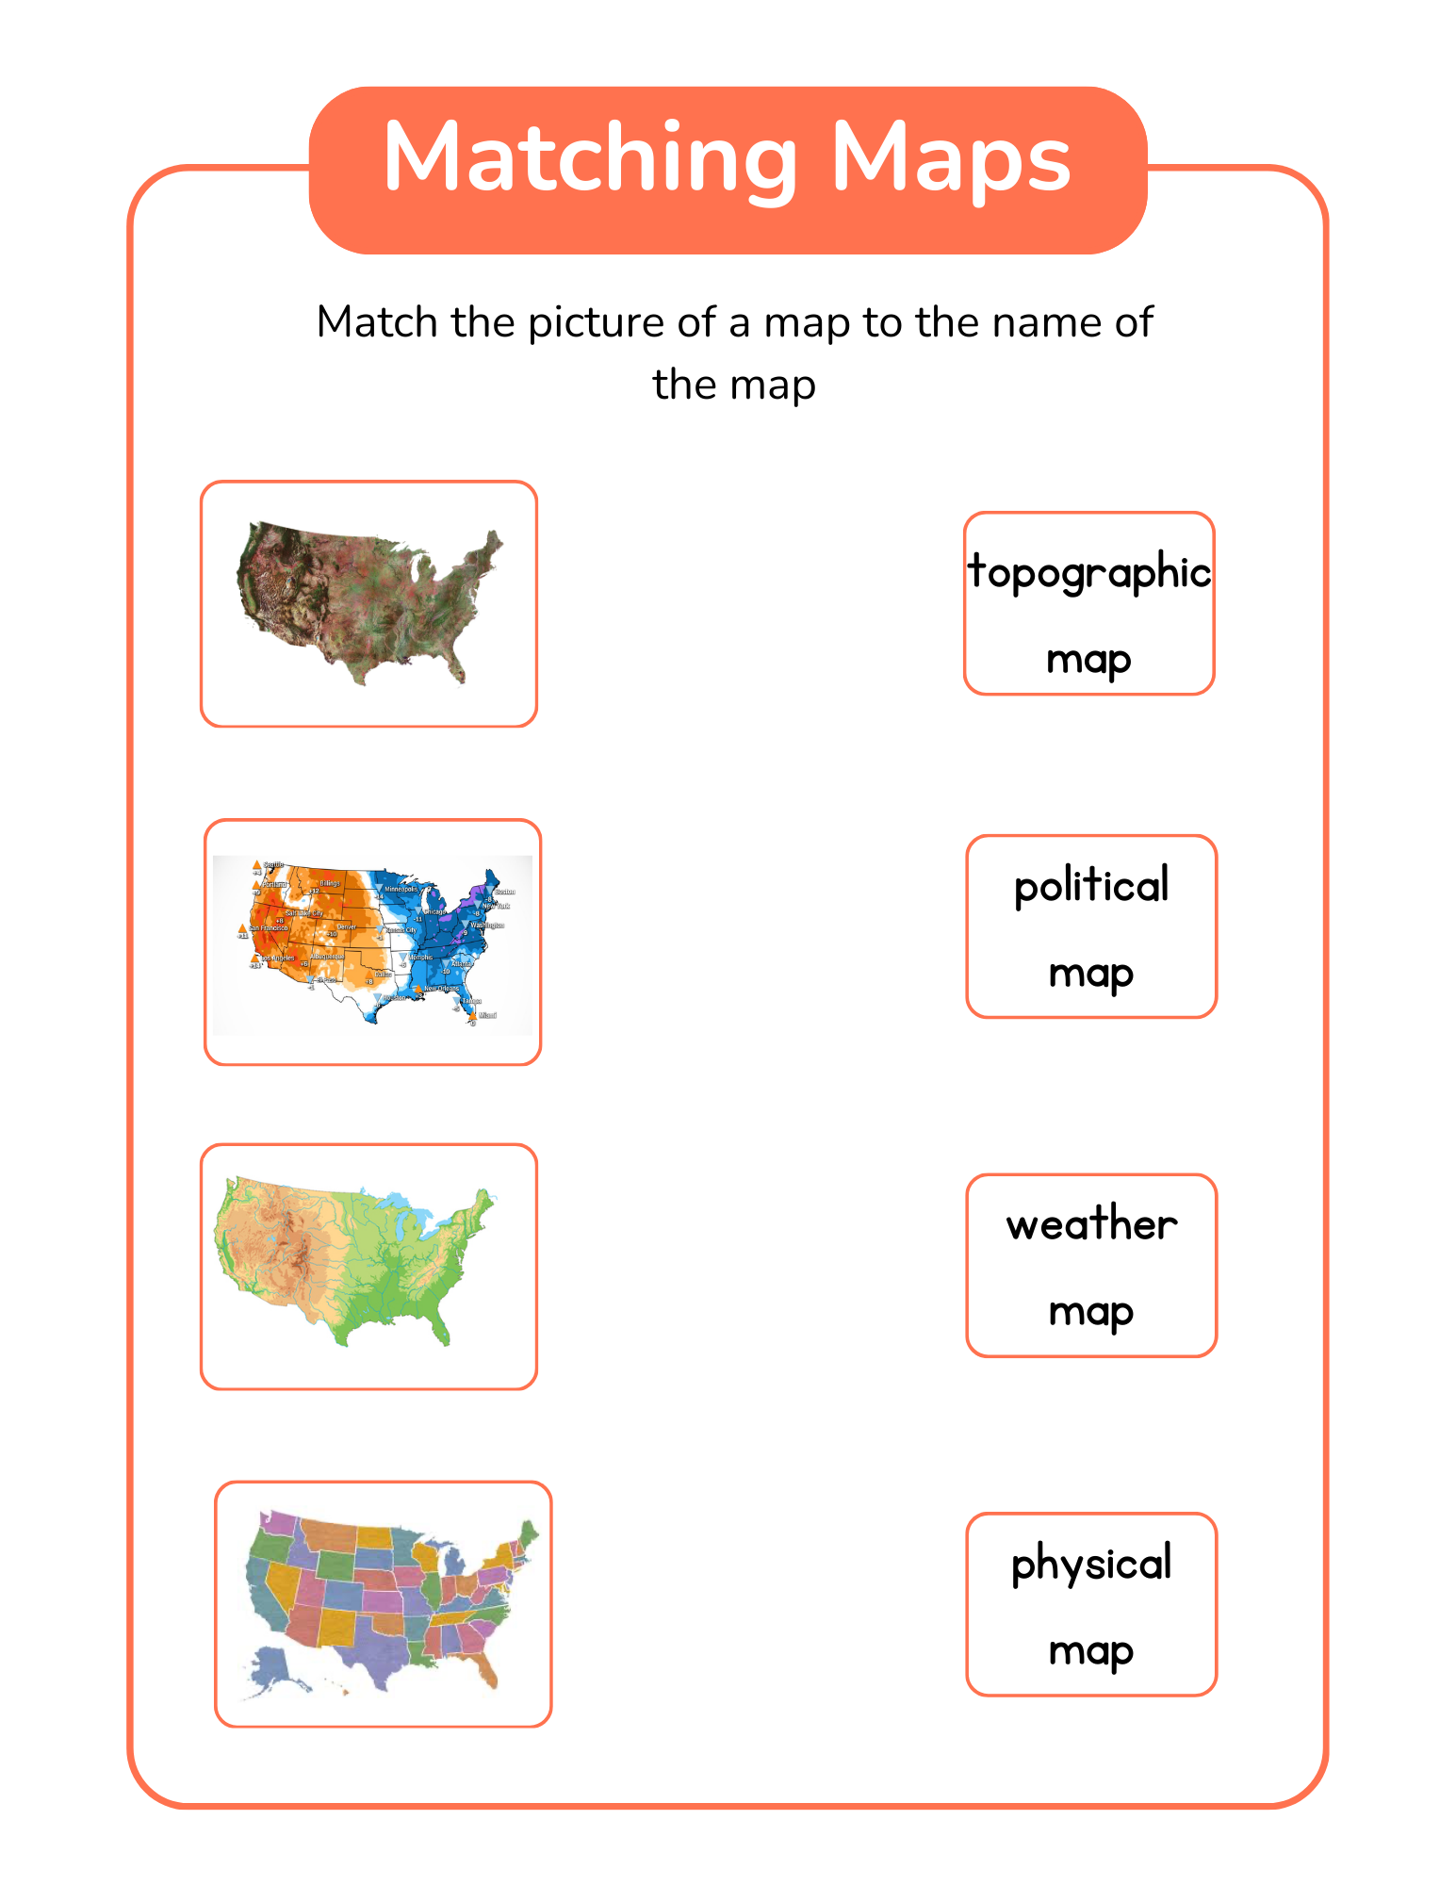

# Anecdotal Notes

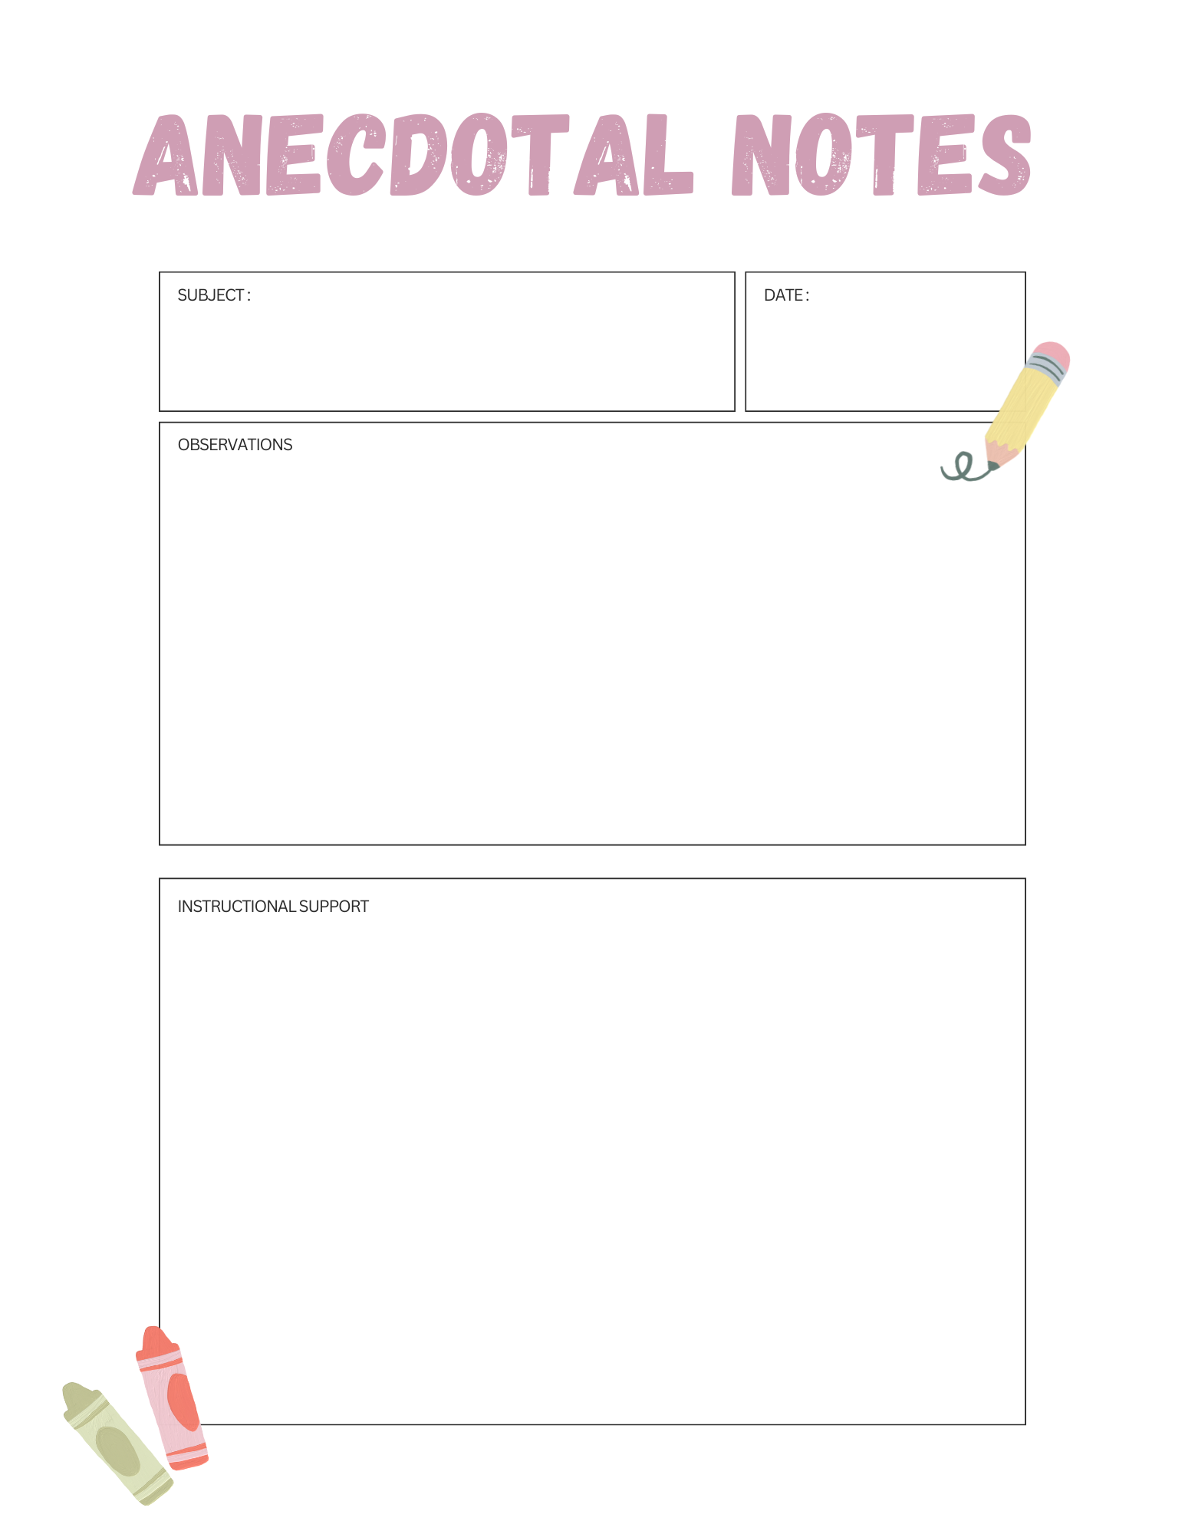

Anecdotal Notes ( Days 13-15)

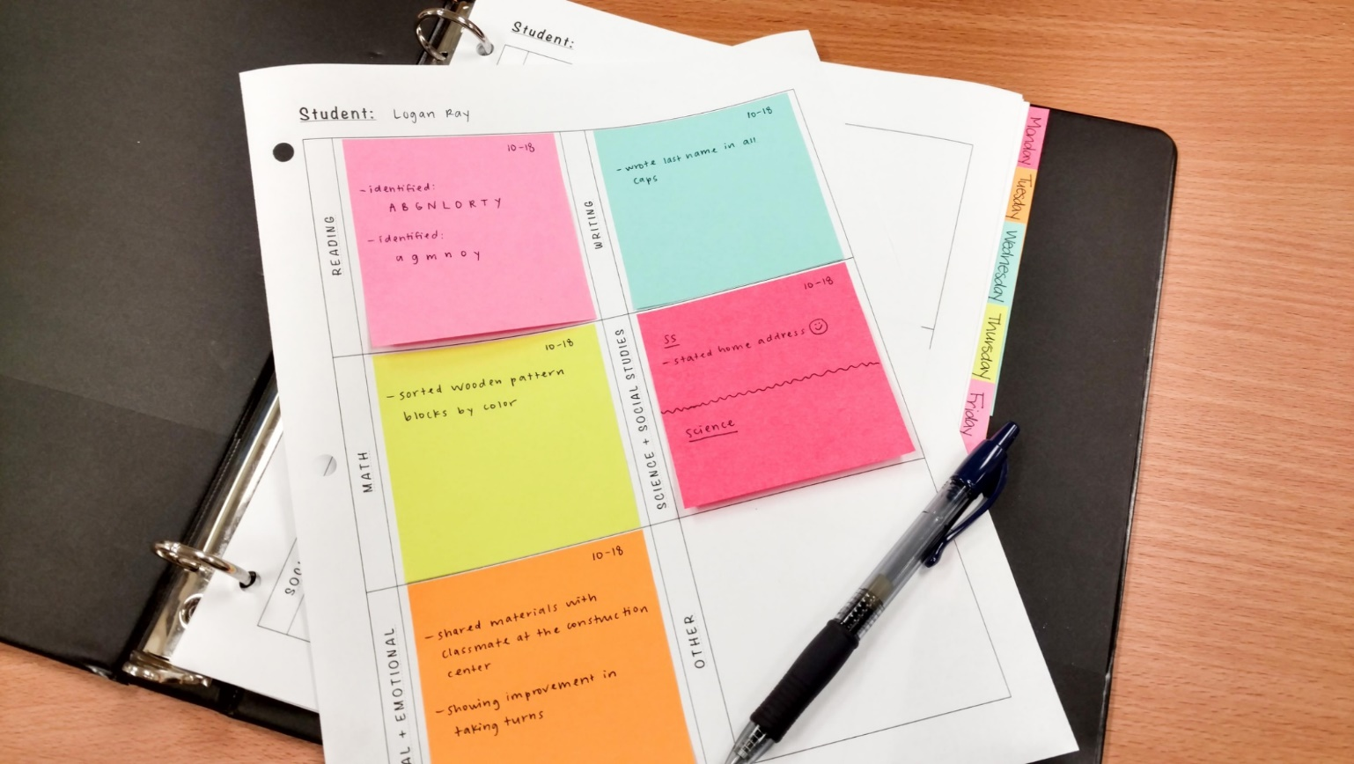

[Group 2: 1st Grade Geography SP24 - Google Slides](https://docs.google.com/presentation/d/1hpq_eD7cH-SkGutEF3EQsyJ5ErPBAZ5kIUL3rWy_tg4/edit#slide=id.g1f569d8c292_1_7)