# Revising an Entry in STARS

You were asked to make revisions to your TOPR submission and resubmit. Here are some technical instructions on how to do that.

1. You received an email that will detail revisions that are requested (Figure 1). When you’re ready to submit the revision, return to the email and click on the revision link that is included in the message.

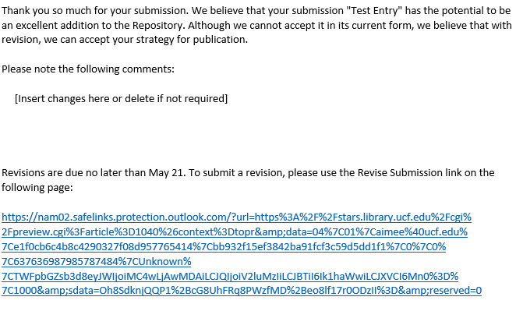  
Figure 1.

1. You will see the screen below (Figure 2). Click on **Revise entry**.

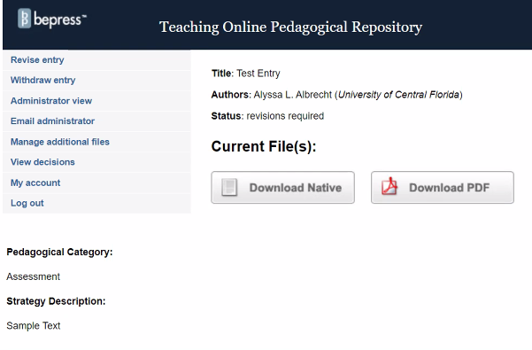  
Figure 2.

1. If you are asked to revise the main contents of your entry submission, upload the revised file (Figure 3).

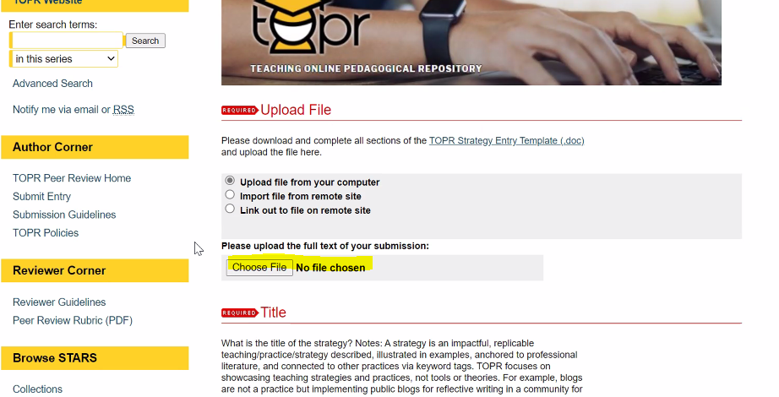  
Figure 3.

1. If you are asked to include additional files (like screenshots, PDFs of rubrics or assignments, etc.), select **Please check this if you’d like to add additional files** which is at the bottom of the entry submission page (Figure 4). Click **Submit** and you will get the chance to upload the supplemental files on the following screen (Figure 5).
   1. Select **Choose File** to upload the new file or files. Once the file or files have been uploaded, click **Continue** to get to the confirmation screen (Figure 6).

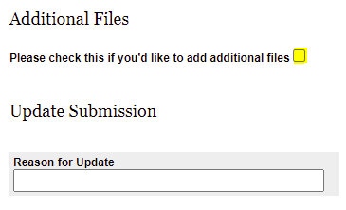  
Figure 4.

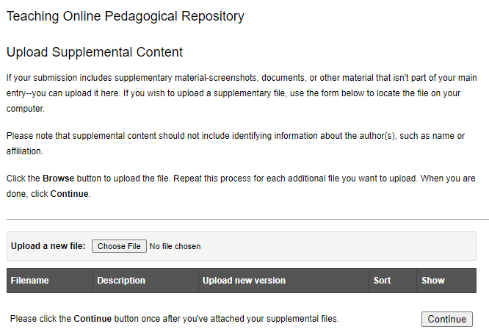  
Figure 5.

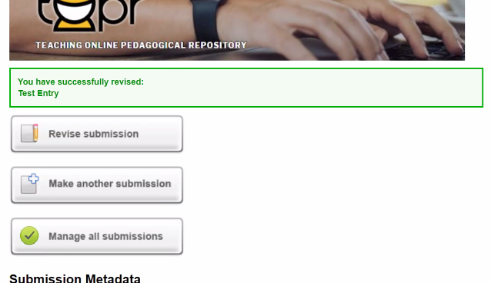  
Figure 6.

If you have any difficulties along the way, please contact [topr@ucf.edu](mailto:topr@ucf.edu)